**FINAL REPORT**

**January 2018**

**United Nations Development Programme Moldova**

**“Strengthening Prevention and Analysis Functions of the National**

**Anticorruption Center (NAC)”**

|  |  |
| --- | --- |
| Reporting Period | August 2015 - January 2018 |
| Donor | Government of Norway  UNDP |
| Country | Republic of Moldova |
| Project Title | “Strengthening Corruption Prevention and Analysis Functions of the National Anticorruption Center (NAC)” |
| Project ID Outputs | 00094126 |
| Implementing Partner(s) | National Anticorruption Center of the Republic of Moldova |
| Project Start Date | August 2015 |
| Project End Date | January 2018 |
| Total resources required | 1,648,395.00 USD |
| UNDP Contact Person | Stefan Liller  Deputy Resident Representative  UNDP Moldova  E-mail: Stefan.Liller@undp.org |

**Table of Contents**

I. Executive Summary 3

II. Background 4

III. Progress Review 5

Output 1: Strengthened NAC´s operational and institutional capacity to fulfill its prevention and analytical functions 5

Output 2: Strengthened NAC´s capacity to implement corruption prevention actions as per national and international strategic documents in coordination and cooperation with other public institutions and CSOs 7

Output 3. Strengthened NAC´s capacity to perform corruption analysis as per national and international strategic documents 22

IV. Project Risks and Issues 27

V. Conclusions and Way Forward 31

VI. Financial Summary 34

Annex 1: Results and Resources Framework 35

Annex 2. Capacity development activities 41

# Executive Summary

The Project has been implemented in compliance with the Project Document which is part of the Cost-Sharing Agreement between the Norwegian Ministry of Foreign Affairs and UNDP Moldova of 26 June 2015. The overall goal of the Project was to strengthen the institutional and operational capacities of the National Anticorruption Centre of the Republic of Moldova for ensuring effective implementation of its prevention and analytical functions in line with the strategic policy documents, such as National Development Strategy Moldova 2020, National Anticorruption Strategy 2011 – 2016, and the National Action Plan for the implementation of the EU-Moldova Association Agreement (AA), as well as with other international commitments of the Republic of Moldova in the anti-corruption area.

In order to achieve the above-mentioned goal, the Project was focusing on a series of catalytic activities aiming to enhance the capacities of the NAC to effectively prevent corruption and to develop and implement evidence-based corruption prevention policies, as well as on strengthening the anti-corruption demand side through facilitating the dialogue between the NAC, civil society and media and through raising public awareness on corruption.

The Project implemented all planned activities thus succeeding in strengthening the institutional and functional capacities of NAC. During the reported period, the Project achieved meaningful and transformative results to enhance corruption prevention efforts of Moldova, in particular adoption of the National Integrity and Anticorruption Strategy 2017-2020 and establishment of the Criminal Assets Recovery Agency. The Project visibly strengthened the capacities of 44 staff members (21 women and 23 men) of the General Division for Preventing Corruption (GDPC) and Corruption Analysis Unit (CAU) in their specific fields of activity. Several key results have been achieved by the Project due to the intensive capacity development. During 2015-2017 NAC performed a total of 13 corruption risks assessment reports, including 4 reports developed with the Project Support in such key sectors as public procurement, private sector, state and municipal enterprises and Chisinau municipality. 11 integrity plans were developed based on the risk assessment reports. The Project also contributed to strengthening the capacities of 700 civil servants at local and central level in assessing corruption risks and drafting integrity plans. The legal acts’ corruption proofing software and specialized training resulted in higher number and better quality and visibility of the legislation corruption proofing reports. Four analytical studies developed with the Project support contributed

to identifying challenges and solutions for improvement on such complex issues, as asset recovery, finality of corruption cases in judiciary, impact of corruption proofing of legislation, and gender and corruption.

The Project was also successful in raising awareness and engaging in corruption prevention activities the civil society, youth and journalists. The anticorruption and integrity awareness campaign targeted around 80% of the population through public events, publications on-line and circulation of video products by different TV channels. Around 1000 young people were engaged in the corruption prevention activities through anticorruption hackathon, contests for drawings on corruption related issues and thematic flash mobs. Developed university and school anticorruption and integrity curricula will contribute to educating young generation in the spirit of integrity. 35 investigative journalists and 45 journalism students strengthened their capacities to better cover and investigate corruption issues through organized contests for the best investigations on corruption related subjects, thematic meetings with NAC staff and open data training.

# Background

The project has been implemented in a complex political environment. Initial phase of the Project coincided with a political and governmental crisis at the end of 2015, which affected the Project and delayed the implementation of some activities, such as drafting of a new National Anticorruption Strategy. The period of 2016 -2017 was characterized by a certain stabilization of political situation and consolidation of the Parliamentary majority. Overall, corruption remained a major problem and challenge for country’s democratic development. At the level of public perception, corruption has been identified among three major issues to be addressed to improve the socio-economic situation in the country, while the trust in main public institutions remained low[1].

At the same time, the Government recognized the need to take firm anti-corruption measures as one of its major priorities, as confirmed in the Government’s Programme 2016 – 2018. Some important progress had been indeed achieved in the anticorruption field. In October 2015, NAC was transferred from the subordination to the Government to the subordination to the Parliament, which significantly contributed to strengthening its independence. A number of important anticorruption legislation was adopted in 2016, including the amended Law on Institutional Integrity Testing;[2] the much-awaited new Law on Prosecution providing for strengthening the Anticorruption Prosecutor’s Office;[3] the package of laws on reforming the National Integrity Commission (NIC) and the system of income and property and personal interests’ declaration. The trend continued in 2017, when other important anticorruption strategic policies have been approved. The National Integrity and Anticorruption Strategy for 2017-2020 (NIAS)[4] and the Law on the Criminal Asset Recovery Agency[5] were approved by the Parliament on March 30, and the framework Integrity Law[6] on May 25. The Criminal Asset Recovery Agency was established in June.

However, the process of reforming national anticorruption system took a longer period than initially envisaged, as the important initiatives not always enjoyed consensus within the Parliament. The NIAS 2017 – 2020 was adopted in the late March 2017, while the Integrity Law - a framework law meant to consolidate the legal framework on anticorruption and integrity - was adopted only in May 2017, while it passed through the first reading in Parliament in July, 2016. These delays affected and delayed the implementation of some of the NAC activities, including the ones implemented with the Project support. In spite of these circumstances, the Project managed to mitigate the emerging risks and to implement all planned activities.

# Progress Review

# Output 1: Strengthened NAC´s operational and institutional capacity to fulfill its prevention and analytical functions

The Project succeeded to visibly strengthen NAC’s operational and institutional capacities to fulfill its prevention and analytical functions. The Capacity Development and Training Plan for 2016-2017 of the NAC corruption prevention and analysis units, developed with the project support on the basis of the comprehensive Capacity Needs Assessment of the NAC performed in 2015, was fully implemented. All 44 staff members (21 women and 23 men) of the General Division for Preventing Corruption (GDPC) and Corruption Analysis Unit (CAU) strengthened their knowledge and skills in their specific fields of activity. In line with the Capacity Development Action Plan, NAC staff benefited from a total of 26 training courses and modules in country and abroad, 12 study visits and participation in 20 sector specific working groups and international conferences. The implemented capacity building activities covered such key issues, as protection of whistle-blowers; project management, communication and public relations; legal aspects and methodologies of corruption risks assessment; developing and implementing anticorruption curricula through e-learning platform; corruption and personal data protection; drafting and monitoring anti-corruption strategies; international anticorruption standards and their application; asset recovery procedures and practices; integrity assessment procedures; human rights aspects of anticorruption, etc. During the study visits GDPC staff learned about the best practices of peer anti-corruption institutions of Croatia, Lithuania, Latvia, Poland, Check Republic, Austria, South Korea, and Hong-Kong.

Several key results have been achieved by the Project due to the intensive capacity development, such as:

* drafting and adoption of an innovative Integrity and Anticorruption Strategy, as a result of a number of trainings in developing, implementing and monitoring anticorruption strategies;
* drafting and adoption of the Law on the Asset Recovery Agency, and establishment of the Criminal Asset Recovery Agency, as the result of the various capacity building activities and study visits in this field;
* higher number and better quality of the corruption risks assessment reports, as well as drafting a new innovative Methodology for corruption risks identification in public entities, to be adopted in 2018, as the result of several trainings on various aspects and methods of corruption risks assessment; a total of 13 corruption risks assessment reports were performed by NAC in the period of 2015-2017;
* developing a draft law on the protection of whistleblowers as the result of the training on this topic;
* higher number and better quality and visibility of the legislation corruption proofing reports, as well as drafting an improved and innovative Methodology for corruption proofing of the legislation based on the human rights approach, as the result of training on legal aspects of corruption risks assessment and human rights training.

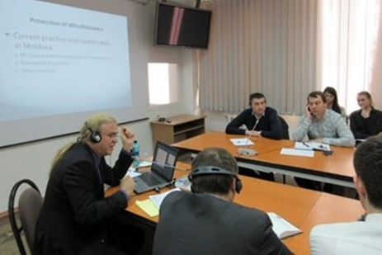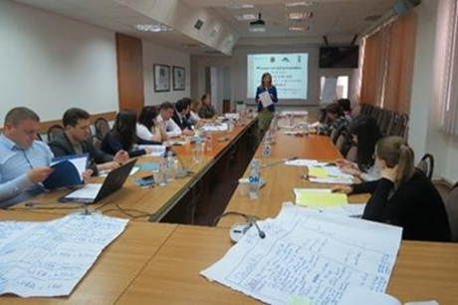

Training in whistleblowing and the protection of whistle-blowers, 12-13 April, NAC



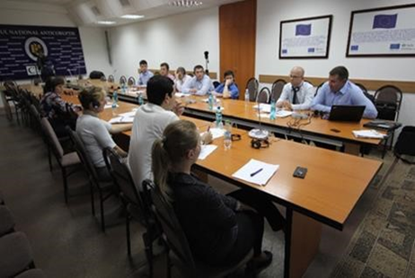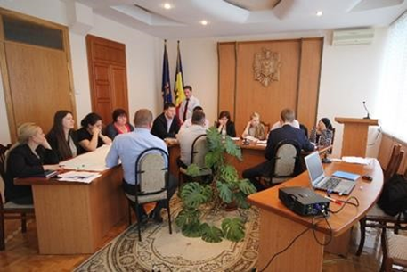

Training on organizing anticorruption training through e-learning platform by the representatives of Polish Anticorruption Bureau, 2 June, 2016, NAC

Training on detection of corruption risks and procedural aspects in public-private partnerships and changing land destination, 2-3 June, 2016, NAC

An important part of the institutional capacity development performed by the Project was the endowment of the NAC Prevention Division with the modern IT equipment and specialized software. Thus, two comprehensive software systems were developed, which will significantly enhance the effectiveness of performance of the staff automating many of the processes that previously had been performed manually:

**The legal acts’ corruption proofing software** was successfully developed and is operational. The new software increased the efficiency of the corruption proofing process by automating the processes and ensuring the traceability at all stages, as well as optimizing the work process and reducing operational costs. It also consolidated the digital archive of the proofed legal and normative acts. The new tool provides a user-friendly access to the non-classified information regarding corruption proofing of legislation process and the content of draft acts liable for proofing to citizens and to private entities. The new software was integrated with the new version of the NAC webpage and offers a user-friendly search-engine for better access of mass-media and public to the results of the expertise[7]. This ensured a greater transparency of the legislative process and an improved quality of laws, while the anticorruption safeguards of the legislative process strengthened.

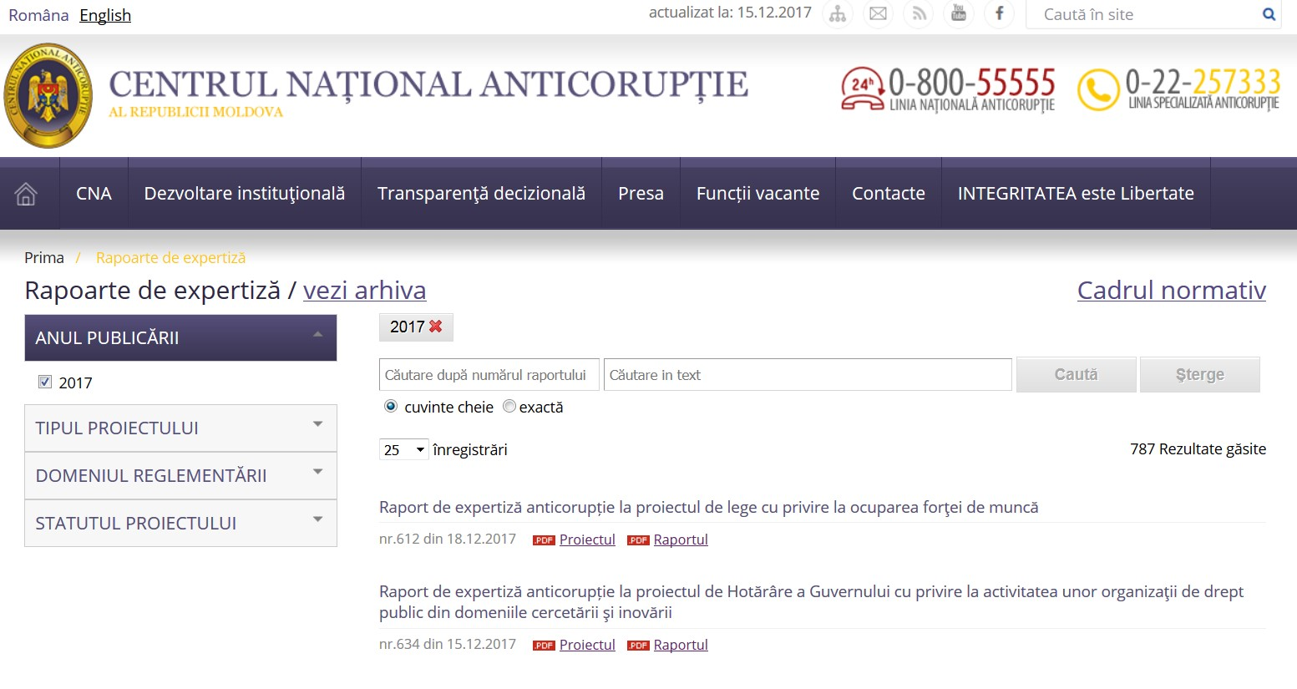

The impact of the Project activity described above is already visible, as the efficiency of the corruption proofing of legal acts has increased in two years of the Project implementation. According to NAC annual reports, in 2017, 842 legal and normative drafts were subject to corruption proofing, compared to 684 in 2015, and 612 in 2014. The effectiveness of the corruption proofing recommendations to eliminate the identified risks calculated by checking the number of accepted recommendations increased by almost 10% in two years: 59,56% of acceptance in 2017 compared to 54% in 2015 and 51% in 2014[8]. Moreover, the increased quality of the anticorruption proofing reports introduced more discipline in the legal drafting process and resulted in higher quality of draft legislation. Thus, in 2015, 10% of draft legal acts did not meet the rules of transparency in decision-making, while in 2017 only 4,85% of draft acts were assessed as non-compliant to this criteria; in 2015, 48% of draft legal acts were not accompanied by the financial justification and indication of the funding source, compared to only 1,62% in 2017; and 55% of draft legal acts regulating business activities were not accompanied by the regulatory impact assessment in 2015, compared to only 0,84 % in 2017.

The Project also contributed to developing capacities of newly established Integrity Assurance Directorate (IAD) within NAC to ensure and speed up the implementation of the Institutional Integrity Testing Law (in force since November 2016). The Directorate was endowed with modern specialized equipment, including work stations and a smart board to ensure promptitude and inter-activeness of the integrity testing activity. In addition, **the new innovative software system** **“e-Integrity Register”** elaborated with the Project support, automates the process of the Institutional integrity testing, and also includes functions that automate monitoring of the implementation of the National Integrity and Anticorruption Strategy.

The “e-Integrity Register” consists of three comprehensive web based application modules. The module „Denouncements” represents a web based platform for the NAC “Hot Line” and other departments where corruption reports may be registered by the NAC employees, by filling in a registration form. The module “Institutional Integrity” ensures integrated management of the phases of the institutional integrity evaluation and management of the institutional risks profile of public institutions. The module „Public Portal for Institutional Integrity” represents a platform for the automated submission by public institutions of the information and reports on the progress achieved in the implementation of the National Integrity and Anticorruption Strategy. The software will become fully operational from 2018.

# Output 2: Strengthened NAC´s capacity to implement corruption prevention actions as per national and international strategic documents in coordination and cooperation with other public institutions and CSOs

* **Support to the elaboration of the National Anticorruption Strategy**

The Project ensured a participative process of the elaboration of the **National Integrity and Anticorruption Strategy (NIAS) 2017 – 2020** involving the civil society experts and organizing public consultations[9]. The Strategy is based on a novel approach of the integrity pillars, based on the internationally recognized methodology of Transparency International. The Project has also offered the expert support to NAC to provide the initial problems diagnosis for each of the NIAS seven pillars and further supported NAC in organizing a total of 15 public discussions of the draft Strategy, including in sectorial working groups. NIAS objectives have a strong linkage with the United Nations Convention against Corruption and the Sustainable Development Goal 16. NIAS focuses on the effective enforcement of the legal and institutional frameworks rather than on legislative modifications and institutional restructuring prioritized in the previous years. This translates into an integrity network reaching at all public institutions at the sector and local levels, as well as ensuring their interconnection with the private sector. The strategy has a robust monitoring and evaluation framework, with clear targets attributed to various state institutions, and accountability at the Ministerial level. Through setting a new paradigm of enforcing integrity instead of focusing on anti-corruption measures and putting the main emphasis on the effective prevention of corruption, NIAS produces a transformative change in the national anticorruption and integrity strategic policy framework.

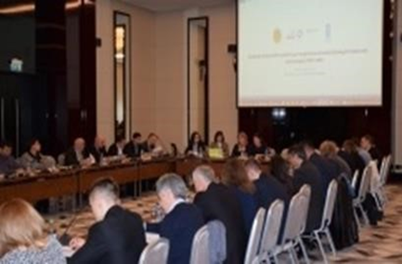 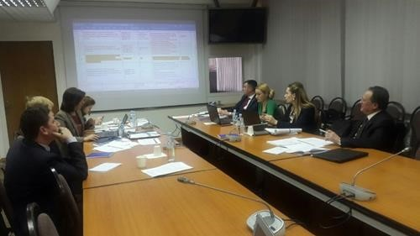

Public consultations on the draft National Integrity and Anticorruption Strategy 2017-2020,

November-December 2016

As the Strategy represents the main national anticorruption policy document, the Project addressed the emerging needs to ensure the timely start of the implementation of the NIAS and offered additional expert support to the NAC in drafting nine anticorruption sector plans in key vulnerable sectors identified in the Strategy: 1) Customs area; 2) Fiscal area; 3) Public procurement; 4) Public property; 5) Health protection and health insurance; 6) Agro-food area (subsidies in agriculture, food safety, and other); 7) Public order; 8) Environment protection; 9) Local public administration. The action plans were drafted in a participatory manner in consultation with main beneficiary institutions, which will assume the ownership over the implementation, and with civil society experts. The action plans are currently at the final review stage and will be approved by March 2018.

**The Project contributed to strengthening NAC capacities to develop evidence based policies.** Thus, in 2015, to provide the baseline indicators for drafting a new National Anticorruption Strategy, the project partnered with Transparency International Moldova in carrying out an opinion survey on perception vs. personal experience with corruption of households and business-people[10]. The Survey results were used during the process of the Strategy drafting. However, as the Strategy drafting process was delayed due to the complex political context, and the National Integrity and Anticorruption Strategy 2017-2020 was adopted only in March 2017, more updated baseline indicators were required. At the same time, one of the issues identified during the process of Strategy drafting, was a lack of available trustful and periodic baseline indicators to ensure effective and objective monitoring and evaluation of NIAS. In this context, to better evaluate the efficiency and impact of the NIAS implementation according to its impact and outcome indicators and to better understand people’s experience with and perception of corruption, the Project supported **the NIAS impact monitoring survey at the national level.** The Survey methodology was designed to measure the NIAS indicators and corruption perception and experience of population, business community and public institutions. The Survey methodology will be used by NAC to measure the NIAS impact on the annual basis and to compare its yearly and final results with the baseline, as envisaged in the Strategy, thus providing a strong tool for the evidence based reporting on the Strategy implementation.

* **Enhancing NAC’s role in assessing corruption risks and implementation of integrity plans in corruption- prone sectors**

**The Project support was instrumental in enhancing NAC’s role in assessing corruption risks and implementation of integrity plans in vulnerable sectors**. The Project supported NAC in performing corruption risks assessment in four key sectors: public procurement, private sector, Chisinau municipality City Hall and state and municipal enterprises. Findings of the reports were used by NAC in drafting and grounding important anticorruption policy documents and law, such as NIAS and the Integrity Law.

A comprehensive **assessment of corruption risks in the national public procurement system** based on the OECD Methodology for the assessment of the national procurement systems included mapping integrity risk areas and recommended 20 measures on improving the legal and institutional framework and business process practices to reduce corruption risks in the system and to increase transparency of the public procurement. The report came with an innovative System of “Red Flag” indicators of fraud and corruption for the whole scope of the procurement process[11]. The public presentation event of the report organized jointly with the Council of Europe, brought together over 50 representatives of central public authorities, development partners, civil society and mass media[12].

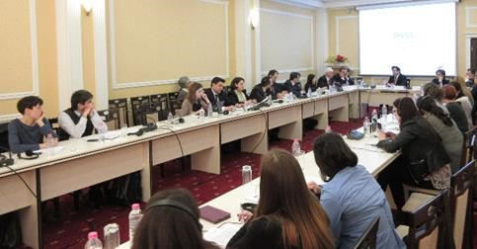The assessment strengthened the capacities of NAC to assess corruption risks in public procurement and provided robust tools for the identification and reduction of corruption in public procurement.

Implementation of the Assessment’s recommendations will align the Moldovan public procurement procedures with the EU directives in the field, including European Anti-Fraud Office (OLAF) directives on the appropriate measures to effectively prevent fraud and corruption in the procurement system. Based on the “Red Flag” system, NAC will develop a guide to be used by the contracting authorities in public procurement process.

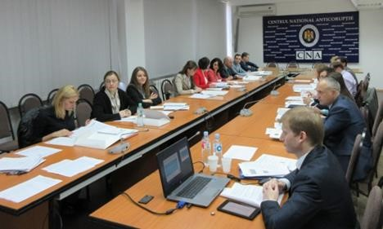To facilitate the application of the Red Flag System, the project supported training of 88 (42 men and 46 women) staff of the internal audit sections from central public authorities and Chisinau municipality city hall. The training focused on the identification and mitigation of corruption risks in the public procurement process on the basis of the developed Red Flag Indicators [13] . NAC continuously uses the Red Flag framework during its training regarding corruption risks in public procurement.



The Project visibly strengthened the capacities of NAC in the analysis of corruption and in promoting integrity standards in the private sector, through support offered in developing **the Assessment on the conformity of the Moldovan national anti-corruption system to main international standards related to corruption and integrity in private sector and a Sample Code of Conduct** **for Small and Medium Enterprises[14]**. This initiative substituted the initially planned risk assessment in the fiscal service due to the NAC request based on its priority needs. In spite of the fact that national legislation provided certain rules on the responsibility of legal entities of private law for a rightful, honorable and adequate entrepreneurial activity and incriminates corruption offences in the private sector, the application of the legal framework has been rather unsatisfactory. The corruption risk assessment of the private sector resulted in a set of 12 recommendations related to better cooperation between anti-corruption authorities and business associations; improving business processes and ethics; internal prevention and control mechanisms for SMEs, etc. It also includes a comprehensive review of the status of compliance of the existing legal framework with the international standards in preventing and combating corruption in the private sector.

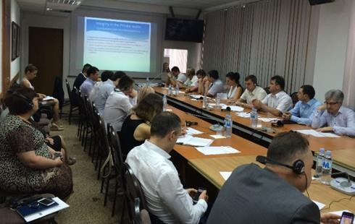The findings and recommendations of the assessment were used as a reference for drafting Pillar VII “Private Sector” of the new National Anticorruption Strategy 2017-2020, as well as in drafting and grounding the framework Integrity Law which includes, for the first time, a chapter on the integrity requirements for private entities. The elaborated Sample Code of Ethics for small and medium enterprises (SMEs) contains a set of principles on conducting a fair, transparent and legal business activity, and sets up the ethical and behavioral rules for the company’s shareholders, management and employees and will be used by NAC to enforce integrity in the private sector under the provisions of NIAS and the Integrity Law.

Presentation of the Corruption Risks Assessment in Private Sector and the Sample Code of Conduct for SMEs to key stakeholders, 29 July, NAC

To further strengthen NAC’s capacities to assess corruption risks in business sector, under the NIAS provisions, the Project offered support to NAC in the process of evaluating **corruption risks in legislation and activity of enterprises with full or majority state/municipal shares**, through conducting a specialized integrity survey of the employees of the state and municipal enterprises. 1,600 employees from 117 state and municipality enterprises participated in the survey as respondents. The results of the survey will be presented as the corruption risks assessment in enterprises with full or majority state/municipal shares is finalized by NAC.

The Project also significantly contributed to strengthening NAC capacities in the assessment of corruption risks and implementation of integrity plans at the local level. **The study on the Assessment of the Impact of Corruption on Good Governance of Chisinau municipality[15]** developed as part of the corruption risks assessment process launched by NAC, came with a thorough analysis of corruption risks and the analysis of the impact (costs) of corruption on good governance in the capital’s administration.

Presentation of the Corruption risks assessment in Chisinau municipality

5 April 2017

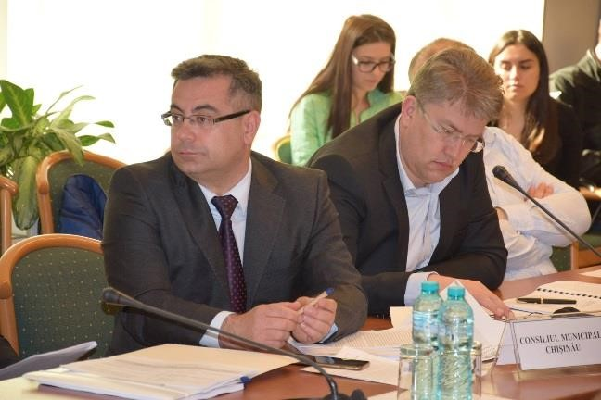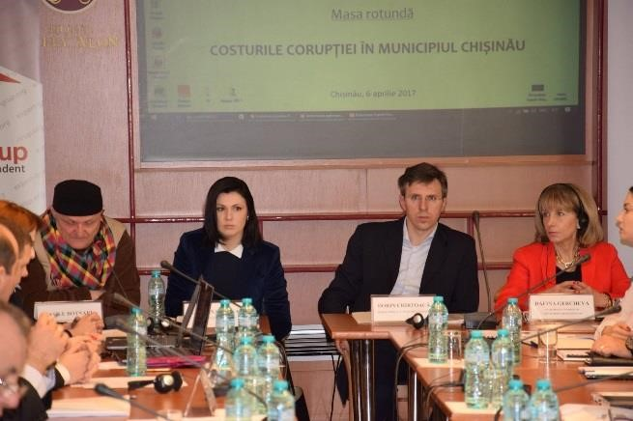

The assessment offered a set of over 30 recommendations aiming at preventing and curbing corruption in Chisinau City Hall in three key areas: (i) Public Procurement, (ii) administration of the public property and assets (privatization, rent and lease contracts); and (iii) decision-making processes in the Municipal Council. It also developed a risk register with a set of recommendations for the mitigation of 57 identified risks of corruption and an analysis of the efficiency of „one-stop-shop” principle in the activity of Chisinau City Hall. According to the experts’ estimations, establishment of a „one-stop-shop” could increase the efficiency of public administration in the municipality by 26%, and could considerably diminish the corruption risks. Worth to mention here about the immediate impact that the Assessment had: the Mayor of Chisinau approved a comprehensive Integrity Plan for Chisinau Mayoralty consisting of 101 actions for 2017-2018.[16]

To better enforce the integrity standards at the local level, the Project supported NAC in **training on the corruption risks assessment of 610 (480 women and 130 men) representatives of local public authorities from 25 (out of total 32) districts (rayons) of Moldova covering about 600 communities**.[17] The participants, including mayors, counsellors, secretaries of local councils, learned how to assess corruption risks and to identify corruption-prone activities using the methodology for assessing corruption risks at the local level made available by the NAC; how to develop solutions for the prevention and treatment of corruption risks through integrity planning and how to keep a risk register, required by the national legislation. Trainings covered the entire country, considering that the remaining 7 districts previously benefited from similar training supported by other partners. The capacities developed through this training proved to be sustainable, as during drafting of anticorruption plans at the local level under the NIAS framework in 2017, the NAC coordinators reported a good level of knowledge of corruption risks management by the LPA representatives. As the result, by the end of 2017, seven local district councils developed and keep corruption risks registers.

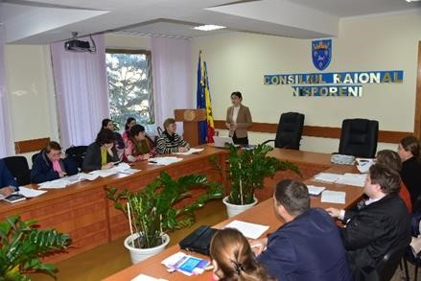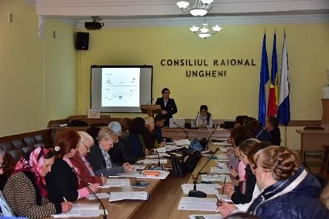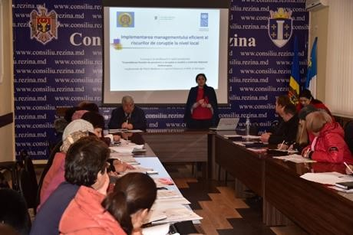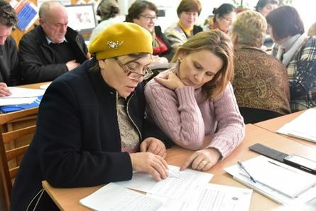

**Training on corruption risks assessment and integrity plans drafting**

**for the representatives of local public authorities, October – December 2016**

➢ **Development of a platform for cooperation between NAC and Civil Society and supporting initiatives promoting youth awareness and engagement in anticorruption**

The Project significantly contributed **to strengthening the transparency and accountability of NAC through engaging civil society, journalists and youth** into anticorruption activities and building their capacities to strengthen the demand-side for enhanced implementation of the anticorruption policies. The Project regularly engaged with and consulted relevant CSOs on major processes and issues, in particular, recommendations of the analytical reports, findings of corruption risk assessment exercises and in drafting the National Integrity and Anticorruption Strategy. CSOs active in the anticorruption field were invited to all public events and presentations organized with the Project support. The international and local experts contracted by the Project had meetings and discussions with the relevant CSOs to hear their opinions and views.

The project **successfully mainstreamed youth involvement and innovation into anticorruption**. The first ever Anticorruption hackathon organized in Moldova and focused on the elaboration of innovative IT applications and solutions targeting citizens’ and youth involvement in preventing and reporting corruption and promoting integrity attracted 80 (61 men and 19 women) young developers, activists and business start-ups. The participants benefited from an intense weekend of applications development assisted by a pool of mentors - technological professionals and governance specialists [(http://hackcorruption.tech/)](http://hackcorruption.tech/))[18][.](http://hackcorruption.tech/)) As the result, two applications using open data were developed and are now operational and sustainable.

1. 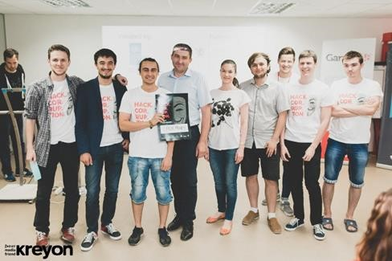**Open Money** [(www.openmoney.md)](http://www.openmoney.md/)– is an application using open data that allows to show the connections between public procurement contracts and final beneficiaries, including institutions, companies and persons. The platform was launched for the public on December 6th, 2016.[19] By January 2018, the [www.openmoney.md](http://www.openmoney.md/) page registered 148,641 total views and 10,887 individual users who visited the platform in 25,019 sessions. On average, there were up to 1000 users per month form Moldova, Estonia, Latvia, Lithuania, Belarus, Russia, Ukraine, USA and UK. The platform was largely mediatized and praised in local media being called “the most useful platform which helps you to see who stays behind the companies having contracts with the state” (quote by Diez.md)[20]. The graphs showing organizational structures of companies available on openmoney.md are used in media for the visualization of facts in published stories. The application was also included in the *Applications* directory of the e-Government Center official open data portal.[21] The team is keen to continue to improve *openmoney.md,*  to add new datasets, such as a NGO registry, pharmaceutical companies’ registry, educational institutions registry and data about political party members/sponsors, based on the feedback from users and is seeking additional funding for the implementation of these plans.

Anticorruption Hackathon, Open Money team

July 8, 2016, Chisinau

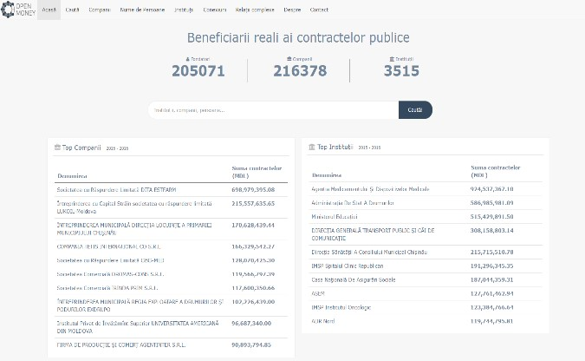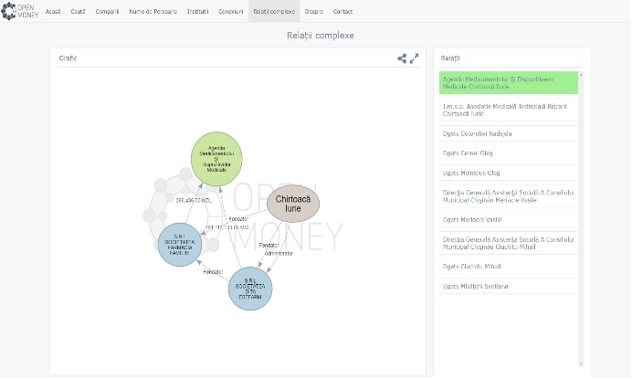

1. Start-In-Moldova [(https://startin.md/ )](https://startin.md/) is a website developed by the Foreign Small Enterprise Alliance that is a one-stop-shop for current and prospective business people to find answers to difficult bureaucratic questions. It aims to be a hub for information about interacting with various public authorities as a business or start-up in Moldova. The base features of the site are a “Q&A System” and the system of “Shared Experiences” where users can ask questions and share experiences with peers in order to get answer and advice. According to the website statistics, the site registered 19,741 visits, on average 40 users are visiting the site per day; 387 registered users posted questions and/or shared experiences, while the top question has over 900 views.

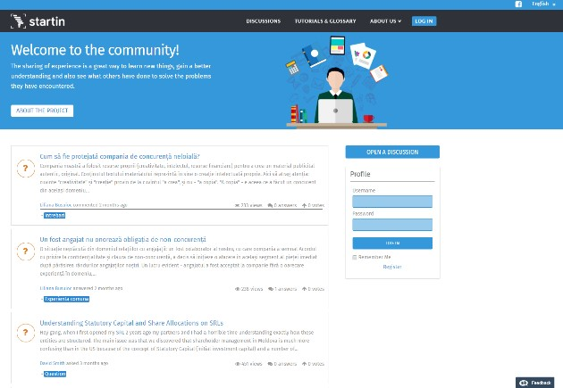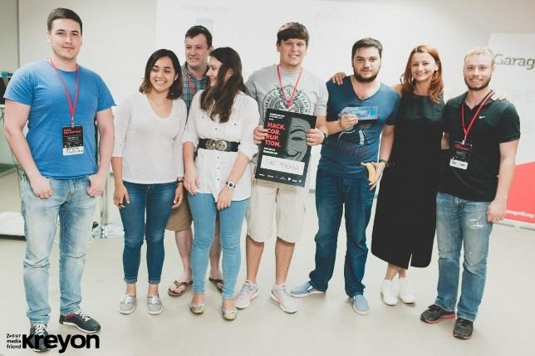

Anticorruption Hackathon, Start-in-Moldova team

July 8, 2016, Chisinau

The hackathon was a successful start and a way forward for engaging youth in innovative anticorruption activities, and also for strengthening the anti-corruption demand side. From the first attempt, it resulted in two innovative fully developed and sustainable solutions tackling corruption in public procurement and private sector, the sectors were Project actively supported NAC’s corruption prevention efforts. Young people demonstrated their readiness to participate in such events and contribute their knowledge and enthusiasm to building innovative products that could help tackle corruption.

Anticorruption Hackathon,

July 8, 2016, Chisinau

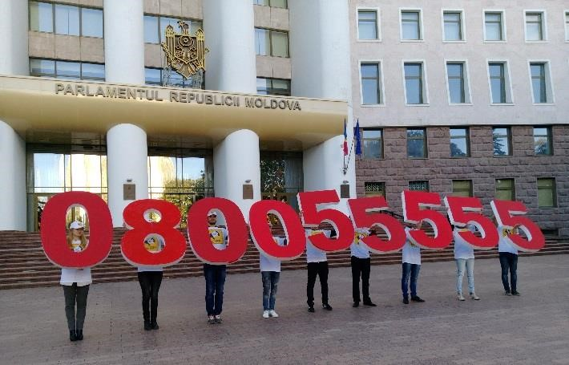**To raise awareness on the corruption phenomenon among youth and increase the young generation’s engagement in anticorruption efforts**, the Project supported NAC in organizing an anticorruption public awareness campaign to encourage citizens to report corruption. A group of students organized a flash mob in front of the Parliament encouraging Moldovan citizens to report corruption on the NAC hot-line[22].

18 October 2016, Chisinau

For three years in the row, the Project supported NAC in organizing **the drawings Contest “Talent does not take bribes. Integrity in Images”**. A total of over 900 boys and girls from all over the country participated in three annual rounds of the Contest and 106 were awarded with prizes. The best drawings were used to publish each year 2,500 Integrity Calendars distributed to central and local authorities, to help promote a "zero tolerance" attitude towards corruption. The drawings were also used for printing of 6000 post cards presenting children’s illustration of corruption in different sectors, such as education, public health, police, customs, and judiciary. The postcards were sent to the relevant public authorities to make civil servants and public officials better aware of the demand side to stop corruption and be more accountable to the public interest.[23] Each year the best art works were exposed in exibitions: in 2015, the drawings blaming corruption were exposed at the Parliament[24], while 2016 and 2017 art works were exposed at a special exposition at the National Art Museum gallery.[25]

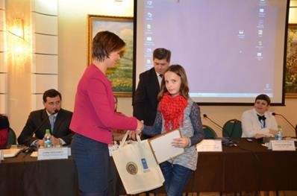

**The drawings Contest “Talent does not take bribes. Integrity in Images”**

**December 2015**

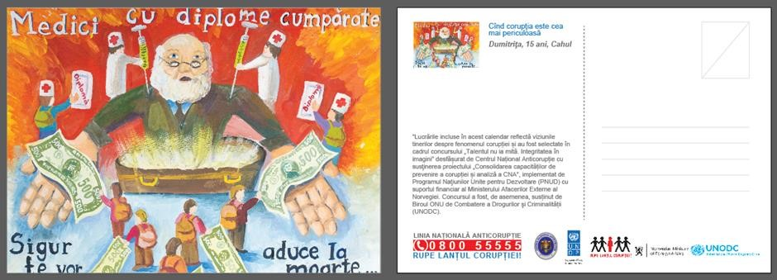

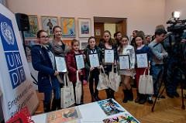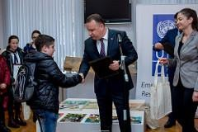

**The drawings Contest “Talent does not take bribes. Integrity in Images”**

**December 2016**

The last 2017 edition of the contest was also the most challenging as the young people were invited to illustrate through drawings, those 12 principles for ensuring the institutional integrity environment, such as conflict of interest, favoritism or professional ethics of the civil servants, etc., provided in the new Integrity Law. The best drawings had been used for printing the 2018 Integrity calendar, where in each month the drawing represents a particular integrity principle to remind public officials about integrity requirements[26].

**The drawings Contest “Talent does not take bribes. Integrity in Images”**

**December 2017**

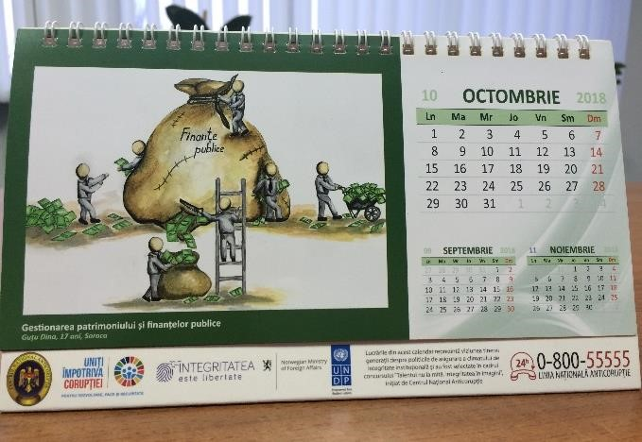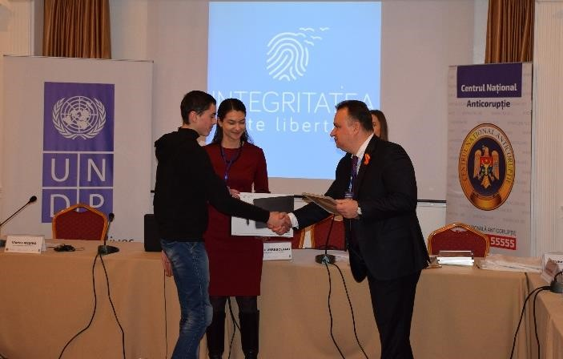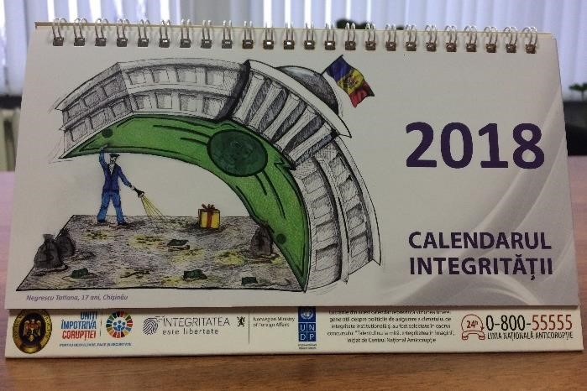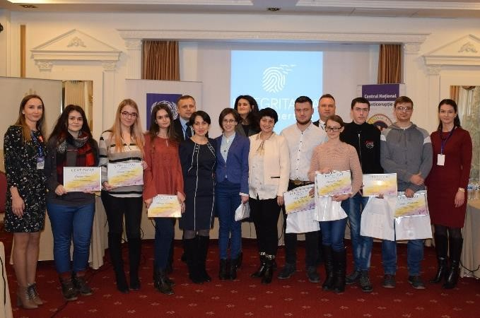

➢ **Promoting open data initiatives and investigative journalism**

**To promote investigative journalism and also to improve NAC’s communication with journalists**, the Project supported three types of targeted activities: off-the-record meetings of the investigative journalists with NAC management, data journalism training and a contest for journalistic investigations.

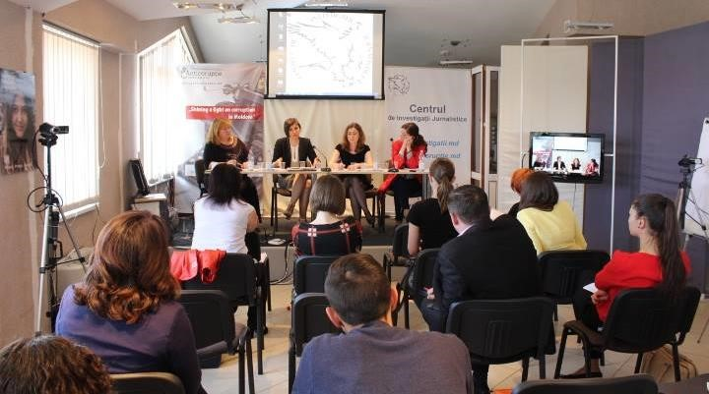The Project supported a series of **closed off-the-record meetings between NAC representatives and investigative journalists** to facilitate cooperation of NAC with mass-media and strengthen journalists’ capacities in investigating corruption cases through better understanding of this phenomenon and of some specific legal and procedural aspects of such investigations. 5 closed and open meetings were organized.



The topics of the meetings included big corruption cases; public discussion of the draft Law on

the Institutional Integrity Testing[27]; the corruption risks in food safety area[28]; and two meetings on corruption risks and hidden interests of officials identified in the draft laws examined by NAC[29]. As a result of the meetings, 24 journalists (9 men and 15 women) improved their knowledge and understanding on the NAC activity and anticorruption issues, 10 investigations were started, of which 3 were published[30].

To strengthen the sustainability of the investment into the investigative journalism, the Project also supported the participation of 2 University journalism professors at an international advanced training course on **open data and investigative journalism**, aimed at improving the skills of journalists in the countries of ECIS and enabling a culture of objective data-based story telling in media through developing and implementing a curriculum in investigative journalism in participating universities. As a follow-up of this training, 6 training modules on data journalism and use of open data in anticorruption investigations were piloted with the participation of **45 journalism students. The participants developed skills in data journalism**, such as available and effective methods and tools for producing relevant and objective investigative materials. At these trainings, journalism students analyzed relevant cases and made practical exercises of searching in open databases on public procurement and on public funds, such as the Ecological Fund, Road Fund, information about schools funding and teachers’ training; property and interests of officials; funding of political parties; data on economic entities and on court cases, etc[31].

**Data journalism and open data training for journalism students**

**Chisinau, September-November 2016.**

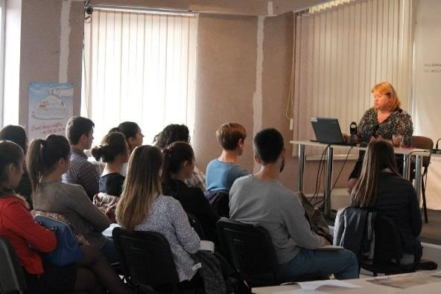

Two editions of **the Contest for the best journalistic investigations on corruption** were organized by the Project to acknowledge the importance of investigative journalism in preventing and fighting corruption and also to raise awareness among the general public and officials. At the first edition, in 2016, 15 journalists (7 women and 8 men), submitted 42 investigations referring to corruption facts, conflicts of interests of public officials, mismanagement of public funds and public property, and undeclared property and businesses of civil servants[32].

**Contest for the best journalistic investigations on corruption**

**Chisinau, 13 December 2016.**

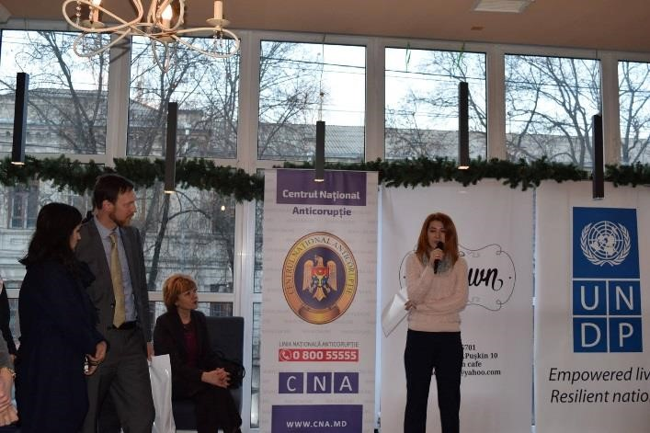

In 2017, the number of journalists participating in the contest increased to 20 (11 men, 7 women and two portals), with 45 submitted materials, which demonstrated an increased interest, demand and capacity for quality investigations[33]. Each year, a pull of professional juries selected 9 best investigations from written, audio, visual and on-line media, awarded with value prizes at the ceremonies held during the Anticorruption week.

**Contest for the best journalistic investigations on corruption**

**Chisinau, 13 December 2017.**

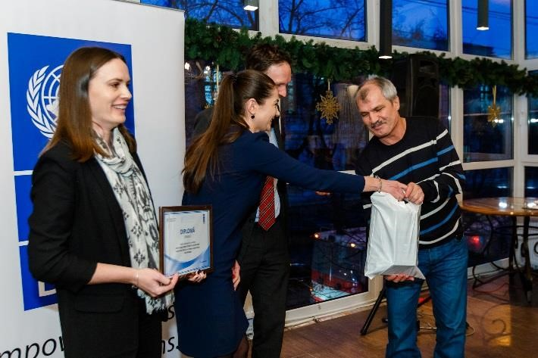

➢ **Strengthening NAC Communication capacities**

The Project visibly contributed to strengthening NAC communication capacities through specialized training in communication and public relations for the staff of the Corruption Prevention Directorate, as mentioned under the output 1, and expert support offered for drafting internal communication policies and for conducting anticorruption public awareness campaigns.

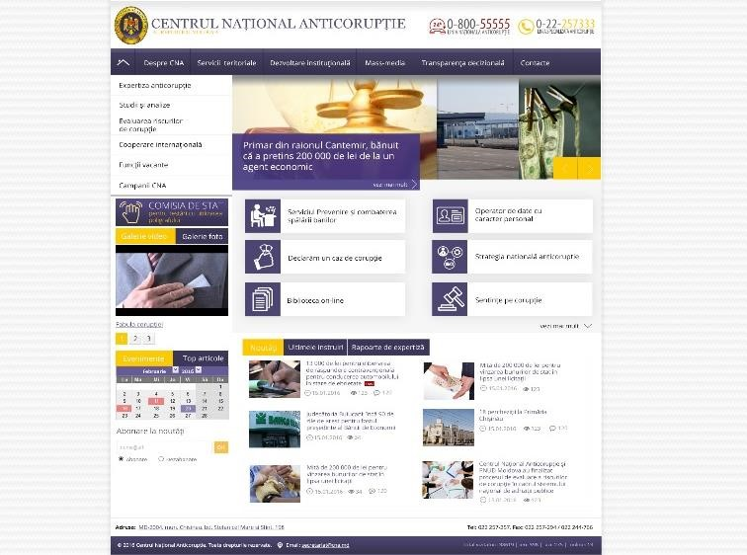NAC Communication Strategy was reviewed and updated with the Project support. To strengthen the NAC outreach to the wider public, the Project also **supported NAC in re-designing its website**.

The new design provides for a user-friendly interface, which is more intuitive, ergonomic and aligned to the most recent technical requirements comparing to the previous version. The system of the content management was changed to adapt it to the NAC needs, ensuring an easy and total management of the web page design, structure and content. The new web page also allows for the integration of NAC electronic applications, such as anticorruption proofing of legal acts, e-learning platform, etc.

As part of the NAC public communication strategy of presenting main progress and evolution in the field of anticorruption, but also to observe the International Anticorruption Day of 9 December, the Project supported NAC in organizing the recent three editions of the National Anticorruption Conference, held traditionally on December 9 each year. At every Conference about 120 participants, representatives of the central and local public authorities, parliament, civil society, development partners and mass media participated and discussed the progress, challenges and lessons learned through the anticorruption efforts of the year.

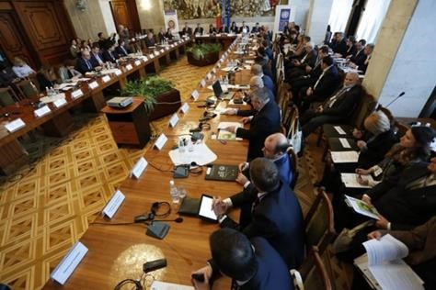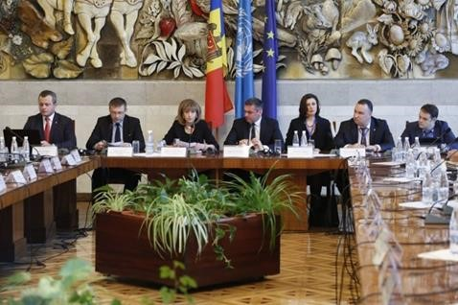

**The XII-th edition of the National Anticorruption Conference**

**Chisinau, 12 December 2016.**

To raise awareness on the corruption phenomenon and the need to promote integrity in the society, the Project supported NAC in implementing a comprehensive **anticorruption awareness campaign with the slogan *Integrity is Freedom***[34]. The general goal of the campaign was to contribute to creating a climate of zero-tolerance to corruption and to promote integrity in the society. The Campaign was based on 20 thematic video products, each having a version in Romanian, Russian and English languages to reach the largest possible audience. The products include a video spot discouraging corrupt behavior by showing emotional and human consequences of being corrupt and 19 fillers representing video tutorials based on the 14 anticorruption/integrity standards included into the framework Integrity law adopted in March 2017. Fillers explain in a simple language using sarcastic presentations various manifestations of corruption and then present the rules to be obeyed by civil servants and by the private entities. In this way, the campaign reaches a twofold impact: educates citizens contributing to a better understanding of corruption manifestations and their rights in relation to civil servants, but also educates and sensitizes civil servants and public officials on the anticorruption regulation and integrity requirements.

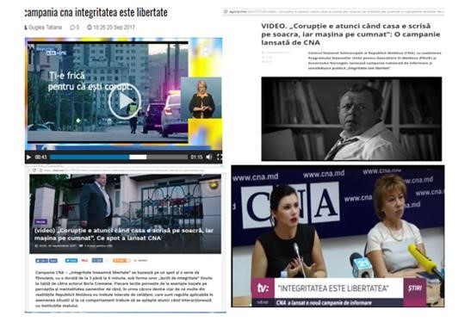In four months, the Campaign targeted dozens of thousands of people through public events, publications on-line and circulation of video products by different TV channels. According to the media report, up to 100,000 users viewed the campaign’s video materials in social networks[35] and up to 1,000,000 people saw the advertised banner of the campaign. As the Campaign’s video products were posted on several TV channels, such as Moldova 1, Publica TV, Jurnal TV, TV8, some with national coverage, reaching the estimated audience of up to 1,000,000 viewers, as well as on the Regional TV networks (Regional TV covering 80% of the localities of Moldova) we estimate that at least 80% of the population were targeted and had seen the Campaign’s products.

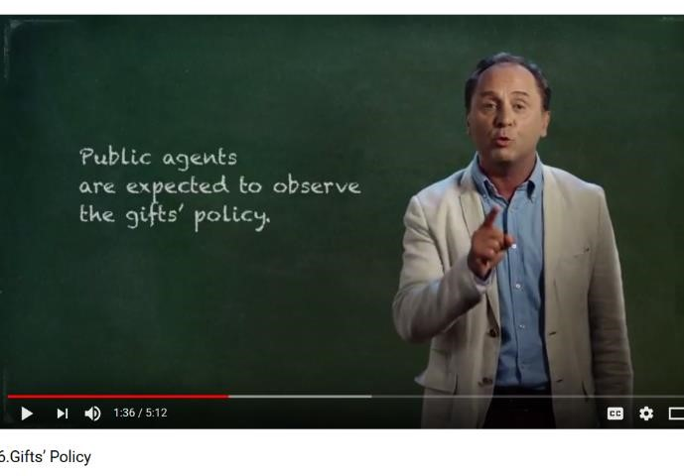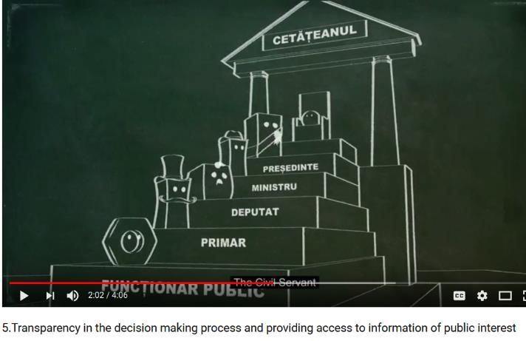

In the framework of the public awareness campaign 55,000 of leaflets explaining provisions of the Institutional Integrity Testing Law were distributed to public institutions, while the Campaign’s banners were posted on official webpages of 24 public institutions. Thus, all public servants were targeted by the Campaign. Moreover, the NAC Anticorruption Awareness and

Education Division uses video tutorials at the integrity and anticorruption training courses, which it offers to public entities. Since the production of video tutorials, NAC staff used these products in 150 training of civil servants from different institutions with an average number of 30 participants per training. As the Campaign’s materials are built on the provisions of the framework Integrity Law, NAC will use this material to educate civil servants and citizen well beyond the Project closure, thus ensuring the sustainability of the Campaign. The produced video tutorials will be also placed on the Integrity module of the e-Learning Anticorruption Platform.

* **Support NAC in promoting anticorruption/integrity education**

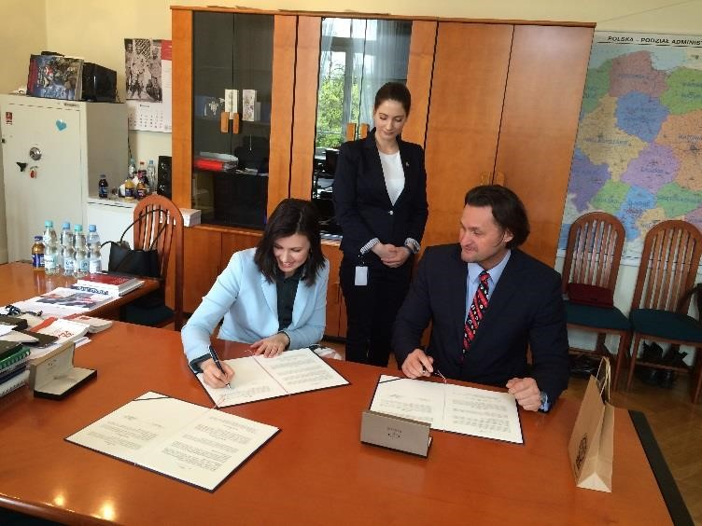To promote anticorruption education making it more accessible and user-friendly,NAC with the Project’s support established a partnership with the Polish Central Bureau for Anticorruption (CBA), which has one of the best regional experiences in using innovative systems of anticorruption education. As an immediate result of the established partnership, the Polish colleagues agreed to share **the e-learning platform (LMS) on anti-corruption education** for civil servants and private sector with the NAC. In April 2017[36], during a visit of the NAC delegation to CBA, the Agreement for the handover of the virtual machine of CBA’s anticorruption LMS was signed, while the Project provided support in adjusting the Platform to the local context and language. Although the initial Project Activity Plan envisaged the elaboration of dedicated on-line training courses for public servants and for schools and Universities, based on the learning the best practice in Poland, NAC took the decision to develop a single anticorruption e-learning platform, which would include on-line training courses for public servants and for schools and universities. The replication of the Polish model allowed for a more effective use of project’s resources. By the end of 2017, NAC experts developed the content for the first LMS module “Integrity in Public Service”, which will be launched as a mandatory course for civil servants from 2018.

**Signing a Memorandum between the Polish Central Anticorruption Bureau (CBA) and NAC for the free transferring of the anticorruption e-Learning Platform**

**Warsaw, 20 April 2017.**

**e-Learning platform on the NAC’s website**

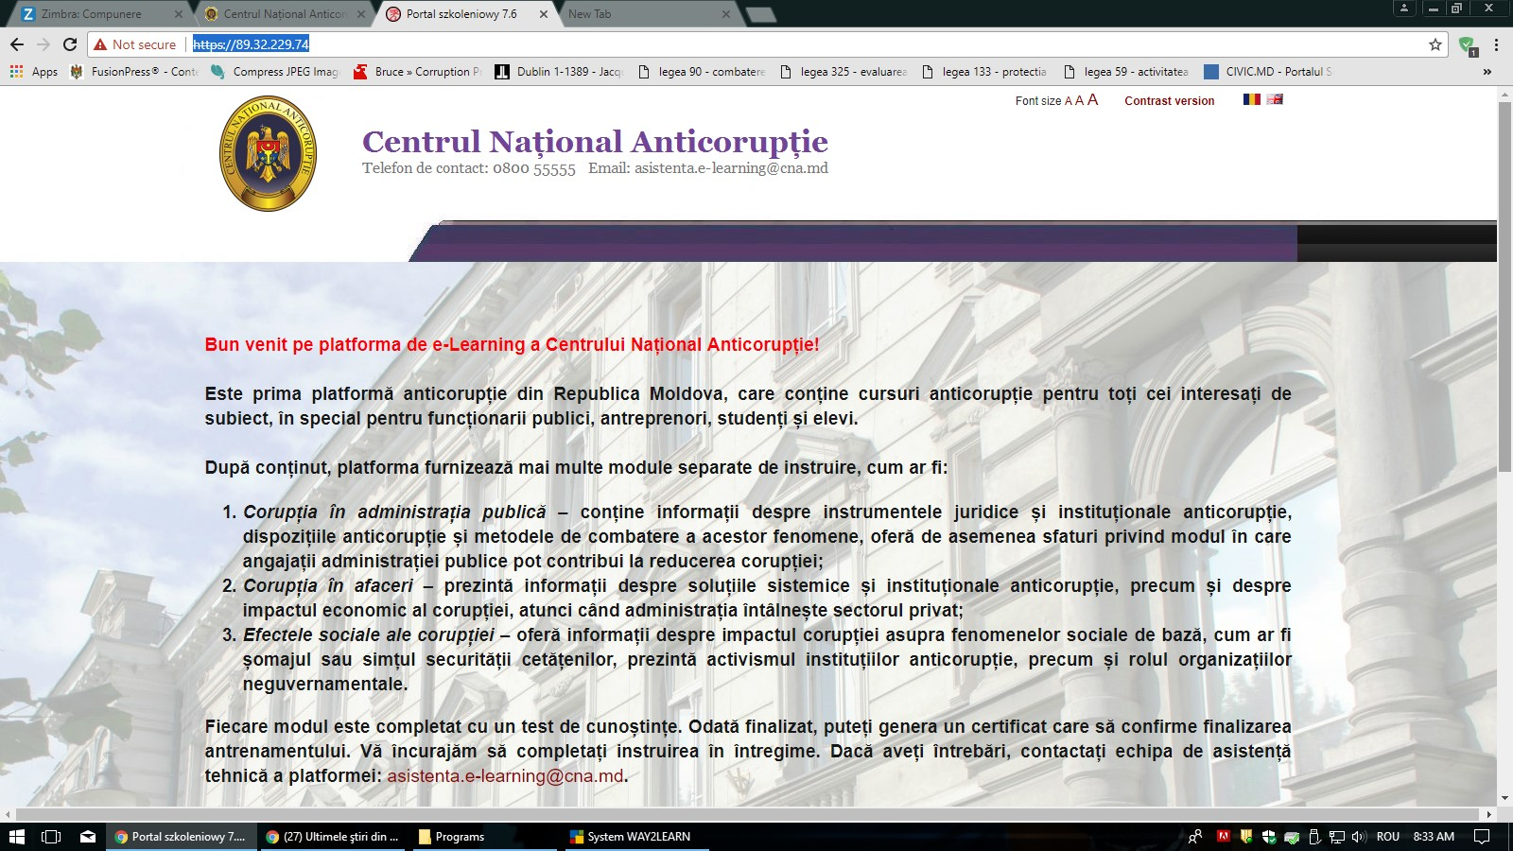

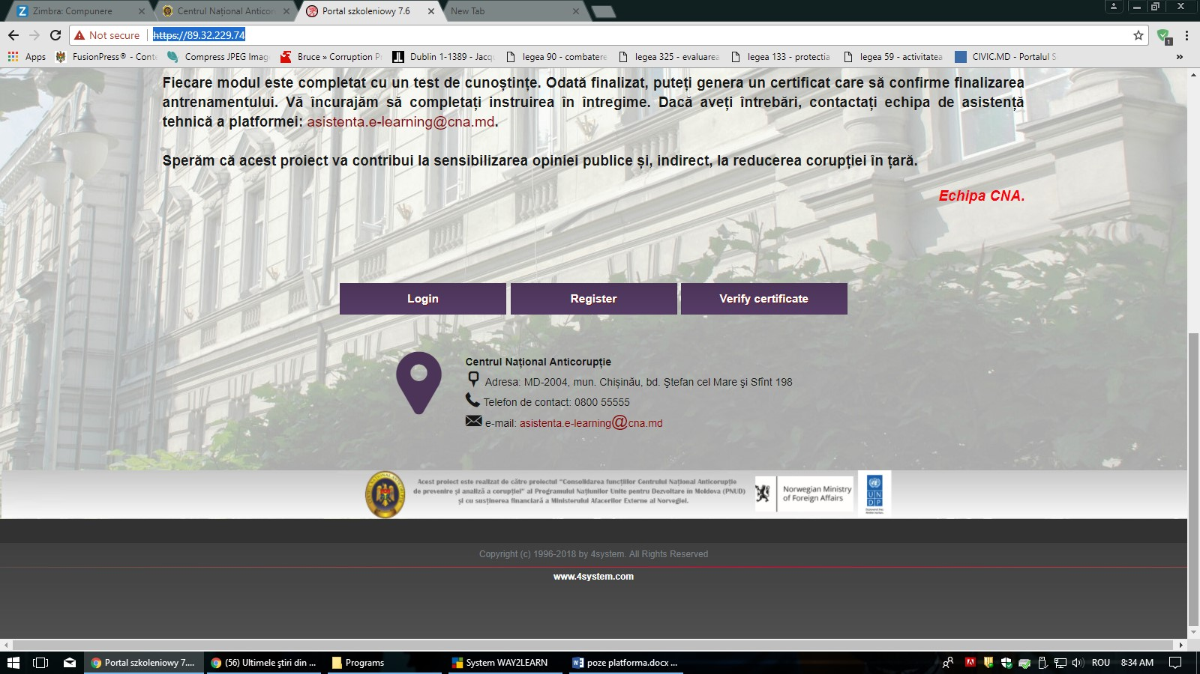

The Project also supported NAC in **developing school and university anticorruption curricula**. Two anticorruption courses for the BA (for non-legal departments) and MA levels were developed and approved by NAC to be further piloted and implemented in universities during 2018. In line with the spirit of the National Integrity and Anticorruption Strategy, but also to bring a more positive perspective on anticorruption education in schools, the Project supported NAC, in coordination with the Ministry of Education, in drafting Integrity education modules for the V – XII school grades, as well as of the methodical guidelines for teaching staff to introduce the modules. It was initially envisaged that Integrity modules would be integrated in the Civic Education curricula. However, as the Ministry of Education launched a reform of reviewing the national school curricula, in line with the new curricular structure, the Integrity Education will be integrated into the Class Management curricula. Under the Order of the Minister of Education, piloting of the Integrity Education Modules was initiated for the V-th grade of school education. To facilitate the piloting process and strengthen the capacities of teaching staff in teaching Integrity modules, the Project supported NAC and the Ministry of Education in training of 70 teachers and school managers (68 women and 2 men) in teaching integrity modules using interactive pupil-centered techniques[37].

**Training for school teaching staff and managers in teaching integrity education**

**Chisinau, November 2017**

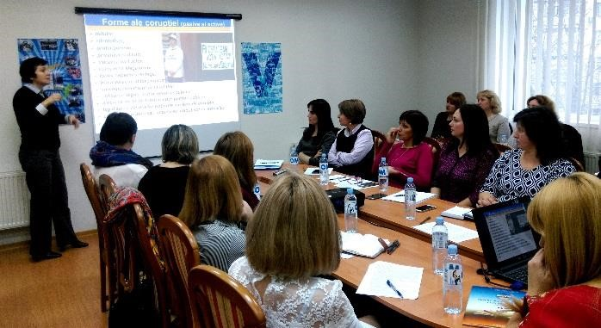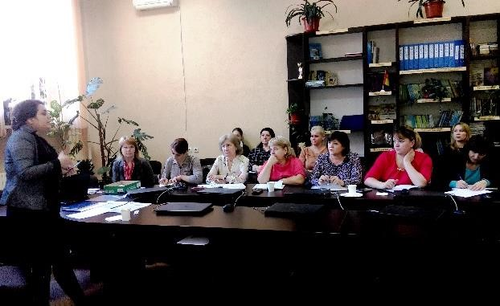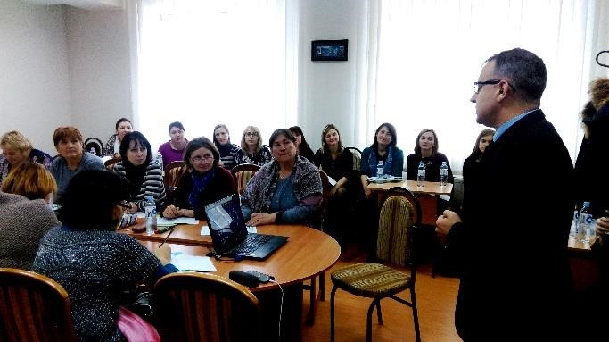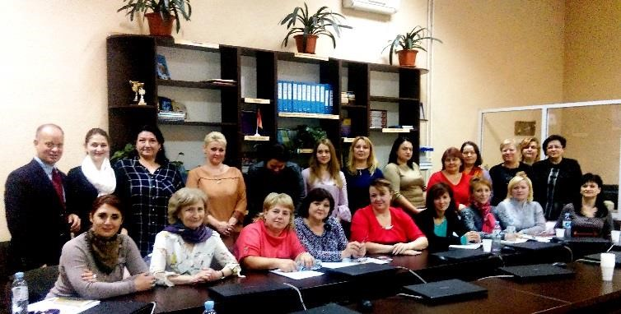

# Output 3. Strengthened NAC´s capacity to perform corruption analysis as per national and international strategic documents

* **Capacity development of the Analytical Unit staff in evidence-based corruption research and analysis**

The Project visibly strengthened the capacities of the NAC Analytical Unit in evidence-based corruption research and analysis through specialized training, exposure to the best practices and expert support offered in drafting comprehensive analytical studies.

All 11 staff members of the Analytical Unit (9 men and 2 women) benefited from the comprehensive specialized training and exposure to best practices during the Project implementation. The staff of the Unit attended two modules of the „Open Source Intelligence” Course organized by one of the most prestigious institutions in the field – the Netherlands International Anti-Crime Academy (IACA)[38]. They have learned about the methods of gathering intelligence information from the Internet by OSINT protocol through the private networks, tracking and analysing digital pictures, tracing the registrants of websites and IP addresses etc. The knowledge received during the visit strengthened the Analytical Unit capacities in the strategic and operational public data analysis, open source data analysis, and in tracking and gathering public data helping to identify corruption. Based on the knowledge and skills developed at the training, the staff of the Unit now uses at large the tools and methods of the analysis of information from the open sources to address corruption risks, particularly in the context of investigating the banking fraud. The Unit staff members also benefited from a training course on the Criminal Analysis and IBM iBase software provided by Police Academy in Szczytno, Poland[39]. The analysts learned how to perform the operational analysis of the crimes using the software database IBM i2 iBase application and management. The training had strengthened the operational capacities of the AU staff that are in charge of further development and administration of corruption crimes evidence systems, with comprehensive analysis of patterns, behavior, criminogenic circumstances, according to the new regulations on the Division’s activity. The earned skills will maximize the usage of the mentioned software, which will contribute substantially to increasing the quality and reducing the time required to develop strategic and operational analysis. The mentioned international expertise was also strengthened in-house during an intensive local training course on using statistical tools and SPSS in creating and managing complex data bases and corruption crimes’ information evidence systems.



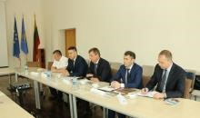 In addition to the training, the Unit staff had also learned best practices of implementing internal information systems, developing analytical reports, carrying out the analysis of mass-media reports and other tools during the study visits to the peer institutions of Poland and Lithuania, as well as to the OLAF Head Office.

Such intensive capacity building resulted in higher productivity of the Unit. Thus, according to the NAC annual reports, the Analytical Unit developed a higher number of analytical products used to prevent and identify corruption cases in 2017, than in two years of 2014-2015: 339[40] and 308[41], respectively. The Unit offered analytical support in the investigation of 189 criminal corruption cases, as well as in the process of anticorruption proofing of legislation offering 46 analytical notes. As the result of the statistical training, the Unit created four databases of the information evidence: (i) crimes, (ii) criminal cases, (iii) courts’ sentences on corruption cases, and (iv) corruption cases reported by mass-media, which will further increase the efficiency of the corruption information analyses.

➢ **Expert support in developing analytical studies on corruption**

T**he Project offered expert support to NAC in drafting four analytical studies** on such complex issues, as asset recovery, finality of corruption cases in judiciary, impact of corruption proofing of legislation, and gender and corruption.

**The Law on the Criminal Assets Recovery Agency (CARA)**, as well as relevant amendments to the secondary legislation were adopted on 30 March 2017[42], based on ***the Study on the effective mechanisms for asset recovery and confiscation[43]*** conducted in 2015 – 2016 in collaboration with the Basel Institute of Governance, the internationally recognized institution specialized in asset recovery. **The Criminal Assets Recovery Agency was established in June 2017**, providing for the first time in Moldova the institutional and legal system for the effective recovery of the assets produced through corruption acts. This activity is an example of how the Project using the emerging opportunities of the favorable political support, on the beneficiary’s request, identified resources to implement additional activities, thus exceeding the planned targets and achieving transformative results.



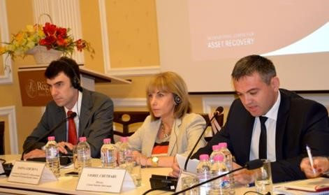 The study provided recommendations on the optimal competences, role and place of a specialized asset recovery office/authority, absent in Moldova at the time, as well as on the effective legislative framework and mechanism for performing financial investigations for the discovery, tracing, preservation and repatriation of proceeds derived from corruption and related crimes. The expert recommended that in Moldova this authority should be established within the National Anticorruption Center, given that it is currently responsible for investigating money laundering, hosts the Financial Intelligence Unit, and has the access to electronic databases. The Study and the Law on the Establishment of the Criminal Assets Recovery Agency gained a vivid interest form the main stakeholders, but also from the press and the civil society. 42 In addition to the planned analytical Study, on the NAC request, the Project supported drafting the Law on the Criminal Assets Recovery Agency based on the Study recommendations. Establishment of the Agency ensures the compliance of the national legislation with the UNCAC Chapter V on Asset Recovery, contributes to achieving SDG 16 (4) target that requires reduction of illicit financial and arms flows, strengthening the recovery and return of stolen assets and combatting all forms of organized crime. It represents an important instrument for curbing corruption and a strong demotivation tool for corruption offences.

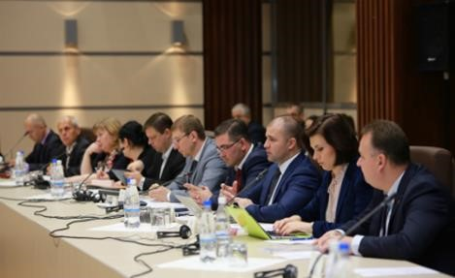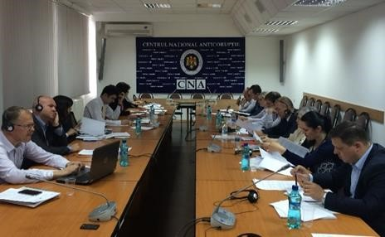



**The Project supported the Study that provided gender responsive indicators to better understand different perceptions and experiences of corruption by men and women working within the central public administration. The Study, titled** as the ***Assessment of the impact of corruption on women’s opportunities for jobs and career in the central public administration[44]*** was based on the UNDP developed Methodology on addressing gender related corruption risks and vulnerabilities in civil service. The Study covered three central public institutions: State Chancellery, Ministry of Labor, Social Protection and Family, and Ministry of Youth and Sports. The report clearly demonstrated that corruption manifestations, such as favoritism, cronyism, influence peddling are felt by women to a greater extent than by men. These, combined with the social barriers, family obligations, but also with the traditional gender roles’ distribution, limit women’s opportunities to strengthen their professional capacities and advance the career in central public administration. The report included a set of 30 specific recommendations for gender considerations related to corruption in policies and in public awareness activities, to gender responsive budgeting, services for women and gender statistics. The Deputy Minister of Labor, Social Protection and Family confirmed that "the relevance of the study consists not only in revealing the risks related to women’s career advancement, but also in coming up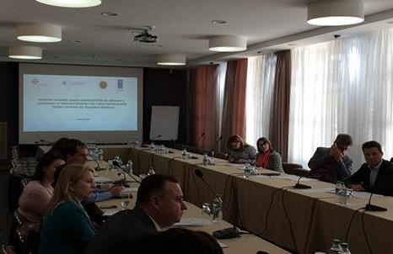 with recommendations that will enhance the capacities of Central Public Administration institutions for ensuring the equal access of women to professional empowerment”.[45] As the follow-up to the Assessment, NAC became more efficient in mainstreaming gender into anticorruption. For the first time, a Session on the Gender influences over corruption, including a presentation of the Assessment, followed by the presentation on the Offender’s profile in corruption cases, prepared by the NAC Analytical division, was included in the agenda of the 2016 National Anticorruption Conference.

Presentation of the Assessment of the impact of corruption on women’s opportunities for jobs and career in the central public authorities, April 28, 2016, Chisinau

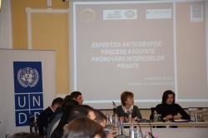 As part of the **impact evaluation of corruption prevention activities**, the Project supported NAC in **evaluating the impact of the anticorruption proofing of legislation** during 2010-2015. The Study ***"The process of legislating interests: qui prodest (who takes advantage)?"***[46]analyzed to what extent private interests could affect the legislative process. Seven categories of private interests had been analyzed: exemption from fiscal and customs fees; debt forgiveness; land use change; public-private partnerships; exemptions from trade rules; creation of the industrial parks; and public authorities budget favoring. The analysis demonstrated that most frequently private or corporate interests were promoted in the field of budget and finance and of the labor legislation, social insurance, health and family. The study represented the first attempt of assessing the cost of the damages caused by promoting interests through draft normative and legislative acts. This assessment demonstrated clearly the effectiveness of the corruption proofing. Thus, according to the estimates of the costs of the draft legislation categorized as promoting some interests (where such estimation was possible), the anticipated public prejudice of legal and normative acts retracted as the result of anticorruption proofing was at 198,340,946 MDL lei (almost USD 10 mln) and public prejudice of legal and normative acts adopted in spite of the anticorruption proofing was estimated at 371,187,304 MDL (USD 18,5 mln). The study serves as an important advocacy tool to strengthen the demand for the anticorruption proofing of legislation, while its recommendations were used to improve the current methodology of corruption proofing, as mentioned under the Output 1.

Presentation of the Study "The process of legislating interests: qui prodest (who takes advantage)?

14 December 2016

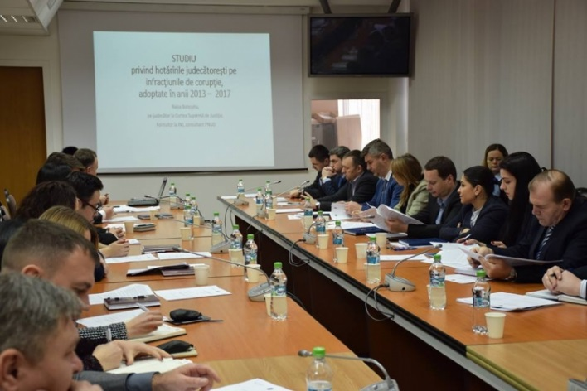**The Project strengthened NAC capacity to address corruption phenomenon in judiciary** through the expert support offered in drafting **an analytical study on the examination of active corruption cases in judicial practice and application of sentences in these cases for the period 2013-2017[47]**. A total of 827 court judgements on corruption cases delivered during the referred period were analyzed. The research found a general improvement of delivering and compiling sentences on corruption cases. Thus, according to a similar study analyzing the period of 2010-2012, the imprisonment with the real execution for corruption cases was only of 1,5%, while, according to the current research, the average for imprisonment with the real execution is 13%. The research also stated improvement in applying fines. Thus, in 2017, fines were applied in 73% of cases comparing to 54% in 2013. At the same time, one of the main findings referred to an excessive and unmotivated de-personalization of the published judgements leading to the limitation of the right to information (70% of decisions in 2016-2017). Among other issues raised in the report was still the lack of a uniform judicial practice in applying sentences for corruption offenses and still a relatively low level (28% in 2017 and an average 47% for the analyzed period) of applying interdiction to occupy certain (public) functions or carry out certain activities for persons convicted for corruption. Study also offered recommendations for improving the judicial practice and the relevant legal framework. Findings of the Study were presented at the National Anticorruption Conference 2017 as well as at a working meeting organized by NAC with participation of the NAC analysts and officers, prosecutors and representatives of the Superior Council of Magistrates.

Presentation of the study on the examination of active corruption cases in judicial practice and application of sentences. NAC, 25 January, 2018

To support the establishment and strengthening of the whistle-blower protection system, the Project offered support to NAC in drafting a Law on whistleblowing and the protection of whistleblowers. Moldova lacks such a law, while the Acton Plan for the implementation of the Justice Sector Reform Strategy (2011 - 2016) envisaged the national whistleblower system to be set by 2016. The international expertise provided was combined with the capacity development activities for the NAC’s staff through a training on the protection of whistleblowers. The developed draft law is currently being consulted with the relevant stakeholders to be approved in 2018.

The Project also supported NAC in developing the Methodology and a Guide on reporting corruption acts, gifts and undue influences, to be used for training civil servants on the compliance with the respective procedures. Currently the guide is under revision by the NAC Legal Department with the aim to adjust it to the provisions of the Integrity Law adopted in summer 2017.

# Project Risks and Issues

|  |  |  |
| --- | --- | --- |
| **Project Title: Strengthening the corruption prevention and analysis functions of the National Anticorruption Centre (NAC)** | **Award ID:** | **Date: 3rd April 2015** |

|  |  |  |  |  |  |  |  |  |  |
| --- | --- | --- | --- | --- | --- | --- | --- | --- | --- |
| **#** | **Description** | **Date**  **Identified** | **Type** | **Impact (I) &**  **Probability (P)**  Scale: 1 (low) – 5  (high) | **Countermeasures / Mngmt response** | **Owner** | **Submitted updated by** | **Last**  **Update** | **Status** |
| 1 | Political instability caused by early general elections | 23.04.2015 | Political | Slow down the implementation of project activities.  P = 2  I = 1 | Depending on the situation, the Project may re-adjust its implementation plans taking into account the new realities. | Project executive | UNDP | 29.05.17 | Risk did not materialize. |
| 2 | Lack of political will to implement effective corruption prevention measures | 23.04.2015 | Political | Reduction in the  project´s influence on corruption  prevention  P: 3  I: 3 | Involving key donors in policy dialogue with the national partners on the effective measures to prevent corruption | Project executive | UNDP | 10.01.18 | Important progress in the anticorruption field was manifested by the approval by the Parliament of the National Integrity and Anticorruption  Strategy for 2017-2020 and the  Law on the Criminal Asset Recovery Agency on March 30 and of the Integrity Law on May 25. However, considering complex political environment, the risk remains valid for the effective implementation of this legislation in the post-Project period. |

|  |  |  |  |  |  |  |  |  |  |
| --- | --- | --- | --- | --- | --- | --- | --- | --- | --- |
|  |  |  |  |  |  |  |  |  |  |
| 3 | Management and  staff turnover in Project’s beneficiary institution | 25.04.2015 | Organisa tional | Delays in project implementation and lack of institutional memory in the  NAC  P = 2  I = 2 | Building non-financial incentives for staff, institutionalization of new tools to build institutional memory and sustainability. | Project executive | UNDP | 08.11.17 | Deputy Director of NAC and National Project Coordinator, Ms Cristina Tarna resigned on 20 October 2017. On October 27, NAC appointed as the Project National Coordinator Mr. Vitalie Verebceanu, Head of the Corruption Prevention Department. The Project activities were not affected by the resignation of Deputy Director except some minor delays in implementation. |
| 4 | Low receptiveness of the NAC employees on the implementation of new knowledge received | 25.04.2015 | Organisa tional | Reduction in the project’s results  sustainability    P = 2  I = 2 | Engage in continuous dialogue with the management of the NAC on the performance of trained employees. Provision of incentives for the implementation of knowledge received. | Project executive | UNDP | 10.01.18 | NAC staff pro-actively applies new knowledge for improving  personal and institutional performance. The risk did not materialize. |
| 5 | Limited interest of cooperation and exchange on behalf of partner institution, lack of commitment on the part of the national authorities to delegate staff for training | 25.04.2015 | Political | Delays in project implementation or impact  P = 2  I = 2 | Engage in a dialogue with the national partners, management of the NAC, to ensure their support and commitment to the staff training. | Project executive | UNDP | 10.01.18 | Project partners have fully engaged in implementation of agreed activities. The risk did not materialize. |
| 6 | Controversial/unexpe cted political decisions | 22.10.2015 | Political | Delays in project implementation or impact  P = 2  I = 2 | Depending on the situation, the Project may re-adjust its implementation plans taking into account the new realities | Project executive | UNDP | 10.01.18 | 6.1. This risk was identified in relation to drafting a new NAS in 2015, when, initially, it had to be elaborated by the end of October, while after the government’s change it was decided to extend the |

|  |  |  |  |  |  |  |  |  |  |
| --- | --- | --- | --- | --- | --- | --- | --- | --- | --- |
|  |  |  |  |  |  |  |  |  | implementation term of the current NAS over 2016. This evolution affected the sequence of the project’s activities  6.2. Another risk related to unexpected decisions is the Parliament’s decision to rethink and to reform the AC institutional framework. The promotion of some legislative initiatives, providing for stronger anticorruption measures, drafted by NAC, was rather difficult. Lack of a clear position regarding the extent to which NAC will be reformed/restructured, created certain delays and deadlocks in its activity and, implicitly, caused delays in implementing some of the Project’s activities, however have not affected the overall implementation framework |
| 7 | Unplanned direct Presidential elections of 30 October 2016 may cause destruction of attention from implementing reforms  and fighting corruption. | 01.09.2016 | Political | Delays in project implementation or impact  P = 2  I = 2 | Depending on the situation, the Project may re-adjust its implementation plans taking into account the new realities | Project Executive | UNDP | 10.01.18 | Risk did not materialize |
| 8 | Unplanned direct Presidential elections of 30 October 2016 may result in unexpected/controver  sial political decisions and indications | 01.09.  2016 | Political | Delays in project implementation or impact  P = 2  I = 2 | Depending on the situation, the Project may re-adjust its implementation plans taking into account the new realities | Project Executive | UNDP | 10.01.18 | Risk did not materialize |
| 9 | Delayed transfer of 2017 installment (due by February 28 according to the contract) due to some technical issues within the NMFA may cause delays in the implementation of some activities which had to be postponed | 15.03.  2017 | Opera tional | Delays in project implementation or impact  P = 3  I = 2 | Engage in a dialogue with the donor to speed up the transfer of the installment; initiate activities which don't require early disbursement of funds | Project Executive | UNDP | 29.05.17 | The funds were transferred on March 29, 2017. Project immediately started implementation of the planned activities. The risk materialized  in 1-2 months delay in implementing some of the activities but did not affect the overall implementation time frame. |

# Conclusions and Way Forward

The Project has been implemented in compliance with the Project Document which is part of the Cost-Sharing Agreement between the Norwegian Ministry of Foreign Affairs and UNDP Moldova of 26 June 2015. According to the Project goal and objectives, it focused on a series of catalytic activities aimed to enhance the capacities, independence and empowerment of the NAC to effectively prevent corruption and to develop and implement evidence-based corruption prevention policies.

The timely identification of the related risks and the measures for their mitigation ensured that the Project implemented all planned activities, even with less financial resources due to the loss due to the currency exchange rate fluctuation, thus succeeding in strengthening the institutional and functional capacities of the NAC. To mention that due to the currency loss, the Project actual budget accounted for USD 1,519,890 against USD 1,648,395 stipulated in the Project Document, based on the exchange rate between Norwegian Krona and USD that existed at the moment of signing the Cost-Sharing Agreement. As regards to the budget implementation, some deviations from the estimative costs of specific activities were generated by the actual financial offers of the service providers obtained through the open competitions, changing the modality of implementation of particular activities, such as contracting international expertise when a specific type of expertise was not available at the local market, etc. These deviations did not affect the general direction, the set of outputs and the nature of activities approved within the Project Document.

The Project achieved meaningful and transformative results to enhance corruption prevention efforts in Moldova, in particular through the adoption of the National Integrity and Anticorruption Strategy 2017-2020, and the establishment of the Criminal Assets Recovery Agency. The Project visibly strengthened the NAC’s capacities to perform high quality corruption proofing of legislation and corruption risks assessments at institutional and sector levels, as well as to produce high quality analytical products and to conduct comprehensive corruption awareness and integrity education campaigns. The Project was also successful in raising awareness and engaging in corruption prevention activities the civil society, youth and mass-media.

The Project ensured a strong sustainability of its results. Thus, the NAC staff has now stronger capacities to effectively prevent corruption, the NIAS will be the main national anticorruption strategic policy framework for the period of 2017 – 2020, well beyond the Project cycle, while the Criminal Assets Recovery Agency is a Government autonomous entity under NAC that will ensure asset recovery from now on. At the same time, corruption prevention is a long-term and complex process, which seldom gives immediate results. In particular, in a transition country with a complex political environment, this process is often lengthened or even may be reversed by the government crises or changes and/or some controversial political decisions. Therefore, further assistance and contributions of all parties are necessary to ensure the continuation of efforts and a sustainable follow up on the achieved results. In particular, further support to the implementation of the National Integrity and Anticorruption Strategy 2017-2020 is important to achieve a strengthened integrity and anticorruption system in Moldova through enhanced anti-corruption capacities of public and private sector institutions to implement the Strategy, and of the civil society to monitor the implementation of integrity requirements and standards.

**Lessons learned**

* ***Need for a certain flexibility in the implementation, as emerging political changes can provide opportunities but also challenges for the Project***

The main challenge and the risk for the project implementation were the controversial/unexpected political decisions in a complex political context, as well as later approval by the Parliament of key anticorruption initiatives. At some stages of the Project implementation such decisions caused delays in the implementation of some important Project activities. Therefore, a certain degree of flexibility in adjusting Project implementation framework was a key factor in adapting appropriate mitigation measures. For example, initially, by the indication of the Prime Minister, the new Anticorruption Strategy had to be elaborated by the end of October 2015. However, after the emerged political crisis and change of Government, it was decided to extend the implementation term of the 2011-2015 Strategy for 2016, while the National Integrity and Anticorruption Strategy 2017-2020 was adopted only in March 2017. Although under the Project initial timeline, the support for the Strategy drafting was planned for 2015, the Project supported NAC in drafting the new Strategy in a participatory manned during the entire lifetime and adjusted its action plan and resources accordingly. On the other hand, using some emerged opportunities of the favorable political support resulted in exceeding the planned targets and achieving transformative results. Thus, in addition to the planned analytical study on the Asset Recovery and Confiscation Mechanisms, the Project, on the Beneficiary’s request, mobilized resources and supported drafting the Law on the Criminal Assets Recovery Agency, which was adopted by the Parliament and the Agency established.

* ***Maintain a constant dialogue with the beneficiary institution***

As mentioned above, the Project had to adjust its action plan to some contextual changes. The successful mitigation measures were determined by a close and permanent dialogue with the decision-making actors from the beneficiary institution. The Project’s localization within the Beneficiary institution was a key factor in facilitating such a close dialogue.

* ***Need for the top level dialogue and engagement to ensure political support and commitment for Project implementation and sustainability of results***

Political will to fight and prevent corruption and political support to the activities and initiatives of anticorruption agencies is a key factor for reaching meaningful results in anticorruption efforts. Introduction of the new and more efficient corruption prevention instruments and regulations not always enjoyed a consensus within the Government and Parliament, and at some stages the process of approval seemed to be deliberately delayed, such as in case of the NIAS, the Law on the Asset Recovery Agency and the Integrity Law. More targeted engagement with the decision-makers might facilitate a faster promotion of such initiatives. At the same time, such a dialogue is important for obtaining a commitment on behalf of the beneficiary institution and at the political level to maintain and further develop the results achieved with the Project support.

* ***Awareness raising anticorruption activities must manage expectations of the general public***

In societies with the high level of corruption and a low level of trust in public institutions it is important to ensure that the public campaigns promoting reforms manage expectations and have messages adjusted to the socio-economic reality and don’t promise immediate results. In case of the *Integrity is Freedom* Campaign, at the beginning there were some negative reactions to the Campaign’s video spot showing negative emotional consequences for a corrupt public servant. Some activists commented that it was rather cynical to blame the corrupt behavior in a state where all public institutions are corrupt. It means that more consistent efforts are needed to gain people’s support for anticorruption reforms in a country with a low level of trust in public institutions and the justice sector.

* **More consistent external communication with media and civil society**

As mentioned in the previous lesson learned, it is much more difficult to gain people’s support for anticorruption reforms in a country with the high level of corruption and a low level of trust in public institutions and the justice sector. In spite of the consistent efforts of the Project to involve targeted SCOs in its activities, the NAC still encountered some problems in getting the support for its corruption prevention initiatives from the civil society, as there was a perception that in a corrupt society all government initiatives have some hidden interests and should be criticized, rather than supported. Therefore, more efforts need to be undertaken to strengthen the cooperation with the civil society, as well as to hold the CSOs better aware of the relevant developments and to further develop the capacities of the CSOs needed for such a constructive cooperation, through targeted joint events, meetings and consultations.

* ***Innovative initiatives imply risks that have to be assumed***

As described under the Output 2, as the result of the Anticorruption Hackathon organized by the project for the first time in Moldova, three applications proposed by young developers were awarded with small grants to support the full development of the ideas. However, only two initiatives were successfully and fully developed. The third awarded grant CoBot was not successful and was only partly developed. Initially CoBoT was meant as a web tool intended to employ artificial intelligence systems to enable gathering, analyzing and classifying citizens’ issues related to corruption. The system aimed to be integrated with the NAC web page to provide tailored information to citizens' questions. However, throughout the development process of the tool, the team encountered difficulties mainly of organizational and technical nature, in line with the foreseen risks. It turned out that the winning idea was as innovative, as it has proven to be not realistic to implement it within the proposed time with the current state of the team’s capacity and knowledge. The project team and the Hackathon’s mentors in various rounds attempted to motivate and support the team including in changing the initial idea towards a less complex platform. However, the team was able to provide only a partial delivery of the application, but not a fully functional and sustainable solution which could be integrated with the NAC information resources and would bring added value for citizens in the anti-corruption realm. The solution was qualified as partly developed and a part of the grant was refunded by the team.

# Financial Summary

|  |  |  |  |  |
| --- | --- | --- | --- | --- |
|  | **2015** | **2016** | **2017** | **2018** |
| **Output 1** | 63,732 | 276,463 | 208,494 | 17,280 |
| **Output 2** | 220,740 | 244,409 | 129,874 | 12,420 |
| **Output 3** | 36,245 | 120,416 | 28,069 | 3,240 |
| **Output 4** | 30,307 | 55,404 | 67,253 | 5,364 |
| **Total** | **340,952.23** | **699,358.88** | **436,462.98** | **38,304** |
| **Total resources: USD 1,519,782.10[48]** | | | | |

# Annex 1: Results and Resources Framework

|  |  |  |  |  |
| --- | --- | --- | --- | --- |
| **Intended Outcome as stated in the Country Programme Results and Resource Framework:**  Increased transparency, accountability and efficiency of central and local public authorities | | | | |
| **Outcome indicators as stated in the Country Programme Results and Resources Framework, including baseline and targets:**  *Outcome 1.1. Increased transparency, accountability and efficiency of central and local public authorities*  ***Indicator***: Confidence in public administration institutions; Corruption Perception Index;  ***Baseline***: 2014: Government: 28%; Parliament: 24%; LPA: 56%; TI CPI: 35  **Target:** Government: 45%; Parliament: 40%; LPA: 60%; Corruption Perception Index: Improvement of the Moldova index; | | | | |
| **Applicable Key Result Area:** Effective Governance | | | | |
| **Partnership Strategy**  Management and staff of National Anti-corruption Centre, experts from relevant sector ministries and departments, NGOs, media, youth, women’s groups and key actors from the donor community will be involved at both the design and implementation phases. Such an approach will provide the basis for reaching consensus amongst all stakeholders and mobilizing all efforts and available resources to foster the proper implementation of actions envisaged and hence the mitigation of development gaps. Close cooperation between the UNDP Moldova and donor Agencies will maximize synergies, ensure coordination, as well as reduce transaction costs and avoid duplication. | | | | |
| **Project title and ID (ATLAS Award ID):** Strengthening the corruption prevention and analysis functions of the National Anticorruption Center (NAC) | | | | |
| **INTENDED OUTPUTS** | **OUTPUT TARGETS FOR (YEARS)** | **INDICATIVE ACTIVITIES/RESULTS**  **2015-2016** | **RESPONSIBLE PARTIES** | **INPUTS** |
| **Output 1:** Strengthened NAC´s operational and institutional capacity to fulfil its prevention and analytical functions  **Baseline:**  NAC Capacity Development and Training Plan non-existing  **Indicators:**  Capacity Development and Training Plan elaborated and implemented;  NAC endowed with modern equipment and specialized software  No. of participants of training (m/w);  No. of participants of study visits and short-term internships (m/w); | **Targets** (year 1 - 2015):  1. Capacity Development and Training Plan for the Prevention and Analysis Units elaborated based on capacity assessment  1.2 NAC endowed with modern equipment and specialized software  **Targets (year 2 - 2016)**  1. Capacity Development and Training Plan for the Prevention and Analysis Units implemented;  1.2 NAC endowed with modern equipment and specialized software  **Targets** **(year 3 - 2017)**  1.1. NAC Capacity Development and Training Plan implemented  1.2.NAC’s corruption proofing of legislation, leading in corruption risk assessment and monitoring on the implementation of NAS improved based on the specialized software and strengthened staff skills  Improved knowledge and operational capacity of NAC officers | 1. 1.1.Achieved. Capacity building Programme for the General Division for Preventing Corruption and Corruption Analysis Unit designed and approved;  1.2. Achieved. NAC endowed with modern equipment and specialized software  1.1. Achieved. All 40 staff memebers of the Prevention and Analytical Unit staff, 20 men and 20 women, have benefited from trainings/exposure to best practices.  1.2. Achieved. Anticorruption profing of legislation software developed.  Development of the Integrity record e-register initiated, technical project developed.     * 1. Achieved. All 44 staff members of the GDPC and CAU strengthened their knowledge and skills in their specific fields of activity   2. Achieved: corruption proofing of legislation software developed and operationl; e-Integrity register including the NIAS monitoring module software developed | UNDP, NAC | Local consultants  International consultants  Training, Workshops and Conferences  Travel  Printing and Publications  Contractual services/ Companies  ICT equipment  Resources planed: USD 530,000  Resources spent: USD 565,969 |
| **Output 2:** Strengthened NAC´s powers to act on priority corruption prevention actions as per national and international strategic documents  **Baseline:** NAC capacity to implement corruption prevention actions as per national and strategic documents is underdeveloped  **Indicators**  2. 2.1 new national anti-corruption strategy elaborated, approved and implemented according to the Action Plan  2.2 assessment of corruption risks and development of integrity plans conducted in at least three vulnerable sectors;  2.3. Cooperation with civil society strengthened through developing a platform for cooperation between NAC and civil society and supporting initiatives promoting youth awareness and engagement in anticorruption;  2.4. Communication Strategy elaborated, approved and implemented according to the Action Plan; | **Targets** (year 1 - 2015)  2. 1 Support NAC in elaboration of the next National Anti-corruption Strategy;  2.2. carry out the assessment of corruption risks in public procurement  2.3 Contests for children and students for the best art works promoting zero-tolerance to corruption organized within the National Anticorruption Conference 2.4. Public opinion poll to define the baseline for monitoring of the Communication Strategy and indicators for monitoring NAS conducted  **Targets (year 2 - 2016)**  2. 1 Support NAC in approving the next National Anti-corruption Strategy;  2.2.1. carry out the assessment of corruption risks in public procurement;  2.2.2. carry out the assessment of corruption risks in fiscal service/sector;  2.2.3. Support to Integrity Plans drafting at CPA and LPA  2.2.4. Support NAC in Elaboration of on-line training courses for public servants;  2.3.1. Support innovative anticorruption solutions;  2.3.2.Contests for children and students for the best art works promoting zero-tolerance to corruption organized within the National Anticorruption Conference;  2.3.3. Support integration of anticorruption issues in school and University curricula; 2.4. Support to review, update and implement NAC Communication Strategy  **Targets** **(year 3 - 2017)**  2.1.On-line anticorruption training courses for public servants developed and operational;  2.2. Institutional transparency through platforms for engaging with Civil Society, mass-media, women and youth enhanced;  2.3.Public opinion polls and awareness campaigns implemented;  2.4.Anticorruption curricula and training programs for schools and Universities piloted and assessed | 2. 2.1. Achieved. The next Anti-corruption Strategy (2016-2018) elaborated and approved;  2.2 Achieved. Final draft assessment of corruption risks in public procurement elaborated and approved;  2.3. Achieved. 530 students participated, 40 best art-works awarded and used for promotional materials to raise awareness on anti-corruption;    2.4. Achieved. Public opinion poll to define the baseline for monitoring of the Communication Strategy and indicators for monitoring NAS conducted  2. 1. The next Anti-corruption Strategy 2017-2020 elaborated and published for consultations; to be adopted at the beginning of 2017;  2.2 1.Achieved;  2.2.2. Achieved. Replaced with private sector by NAC request, Assessment elaborated, approved and published.  2.2.3. Achieved. 610 responsible staff from 25 districts trained to assess corruption risks and draft integrity plans/risk registers  2.2.4. Transferred for 2017;  2.3.1. Achieved. Anticorruption Hackathon held; 80 young people participated; 3 innovative solutions awarded and partly developed;  2.3.2. Achieved; Over 300 pupils participated, 50 best art-works awarded and used for promotional materials to raise awareness on anti-corruption  2.3.3. Achieved. University BA and MA course developed and approved; school curricula initiated;  2.4. Achieved. Strategy reviewed and updated; NAC website redesigned  2.1. Achieved. The e-learning platform developed.   * 1. Achieved. Contest for best journalistic investigations organized; Contests for students for the best art works promoting zero-tolerance to corruption organized. A total of up to 1000 young people and 80 journalists including journalism students engaged in anti-corruption activities.   2. Achieved. National Integrity and Anticorruption Strategy impact monitoring survey conducted; Anti-corruption awareness campaign implemented. At least 80% of the population was targeted; 50,000 of informational leaflets distributed to public institutions in the country.   3. Achieved. University and school curricula developed and is in the process of piloting. | UNDP, NAC | Local consultants  International consultants  Training, Workshops and Conferences  Travel  Printing and Publications  Contractual services/ Companies  Audio Visual and Print production  Resources planed: USD 650,000  Resources spent: USD 607,443 |
| **Output 3:** Strengthened NAC´s capacity to priority corruption analysis as per national and international strategic documents  **Baseline:**  NAC capacity to perform corruption analysis is underdeveloped  **Indicators:**  3. 3.1. Analytical studies on corruption analysis in at least three priority sectors elaborated;  3.2. AU staff exposed to best practices in EU MSs.  - No. of staff with enhanced skills for research and analysis;  3.3. Gender disaggregated risks of corruption assessed | **Targets** (year 1 – 2015)  3. 3.1. Support Analytical Unit staff to expose to best practices in EU MSs;  3.2. Elaborate analytical study on asset recovery and extended confiscation;  3.3. Conduct the assessment on the impact of corruption on women’s opportunities for jobs and career in the central public authorities in line with the UNDP Methodology  **Targets** **(year 2- 2016)**  3. 3.1. Support Analytical Unit staff to expose to best practices in EU MSs;  3.2.1. Elaborate analytical study on asset recovery and extended confiscation;  3.2.2. Elaborate analytical study on the application of whistle-blower and protection of whistle-blowers  3.2.3. Develop Methodology and a Guide on monitoring the life-style of civil servants;  3.3. Conduct the assessment on the impact of corruption on women’s opportunities for jobs and career in the central public authorities in line with the UNDP Methodology  **Targets** **(year 3 - 2017)**  3.1.Three analytical studies developed, discussed and published;  3.2. Impact assessment of the impact of corruption prevention activities’ recommendations implemented | 3.1. Achieved. Draft analytical study on asset recovery and extended confiscation elaborated;  3.2. Achieved. Three staff trained on techniques to analyze the transparency of European external assistance projects implementation;  3.3. Achieved. Data for Assessment on the impact of corruption on women’s opportunities for jobs and career in three central public authorities collected  3. 3.1. Achieved  3.2.1. Achieved; Law on the Asset Recovery based on the study’s findings and recommendations adopted in the first reading;  3.2.2. Achieved. On the NAC request, instead of a study, a draft law on the protection of whistleblowers was drafted  and capacity development activities for the NAC’s staff through training provided  3.2.3. Achieved. On the NAC request was replaced with the Methodology on reporting corruption, gifts and undue influences;  3.3. Achieved   * 1. Achieved.   2. Achieved. | UNDP, NAC | Local consultants  International consultants  Training, Workshops and Conferences  Travel  Printing and Publications  Contractual services/ Companies    Resources planed: USD 220,000  Resources spent: USD 188,150 |
| **Project management** |  |  |  | Contract Services/ Individuals;  Contract Services/ Companies  Equipment and Furniture  ICT equipment  Communications and audio visual  Rental& Maintenance - Premises  Travel  Resources planed: USD 120,000;  Resources spent: USD 158,328  NAC in-kind contribution USD 30,000 (project premises, staff time) |

# Annex 2. Capacity development activities

|  |  |  |  |  |  |
| --- | --- | --- | --- | --- | --- |
| **Training courses abroad** | |  |  |  |  |
| **No.** | **Purpose** | **Destination** | **No. participants** | **Men** | **Women** |
|  | Participation at one week training course/Internship on undercover investigation activities of the staff of the Integrity Testing Division, Marcel Tabarcea (Head of division) and Vasile Dobinda organized by the Polish Central Anticorruption Bureau (CBA) | Lucien, Poland,  7 – 13 November, 2015 | 3 | 3 | 0 |
|  | Internship at Central Anticorruption Bureau of the Republic of Poland | Warsaw, Poland, 03-14 October, 2016 | 1 | 0 | 1 |
|  | Training Course on Singapore's Anti-corruption Strategies (co-funding) | Singapore, 27 June – 01 July, 2016 | 1 | 0 | 1 |
|  | Training course for the Analytical Unit staff at the International Anti-Crime Academy | Breda, Netherlands, 22 – 25 August, 2016 | 7 | 7 | 0 |
|  | Data Journalism Bootcamp/training for journalism university professors (co-funding) | Danilovgrad, Montenegro, 16-26 August, 2016 | 2 | 0 | 2 |
|  | Training for the Analytical Unit staff on Criminal Analysis and IBM iBase software provided by Polish Police Academy | Szczytno, Poland, 12-23 September, 2016 | 4 | 4 | 0 |
|  | Training on Personal Data Protection in the European Union organized by the European Institute of Romania | Bucharest, Romania, 12-13 September, 2016 | 2 | 1 | 1 |
|  | ICAC (Hong-Kong Independent Commission Against Corruption) International Seminar with the theme “Cutting the Financial Vein of the Corrupt” and in a specialized training on financial investigation and asset recovery methodology and strategy | Hong Kong, China, 09-12 May 2017 | 3 | 1 | 2 |
|  | Course on “Preventing and combating corruption 2017”, organized by the European Institute of Romania | Bucharest, Romania,  29-31 May 2017 | 3 | 0 | 3 |
|  | 2017 ACRC Training Course for International Anti-Corruption Practitioners | Seoul, Sejong, Cheongju, Republic of Korea, 17-26 April 2017 | 1 | 1 | 0 |
| **Training courses in Moldova** | | | | | |
|  | Whistleblowing and the Protection of Whistle-blowers in Moldova, NAC staff | Chisinau, Moldova, 12– 13 April, 2016 | 31 | 20 | 11 |
|  | Project management and project writing, communication and public relations, NAC staff | Chisinau, Moldova, 19-21 April, 2016 | 27 | 12 | 15 |
|  | Management of corruption risks related to the public procurement process, internal auditors of the central public administration authorities and Chisinau City Hall | Chisinau, Moldova, 19 May – 2 June, 2016 | 88 | 42 | 46 |
|  | Detecting risks of corruption and procedural aspects of public procurement process, NAC staff | Chisinau, Moldova, 10 June, 2016 | 7 | 2 | 5 |
|  | Developing and implementing anticorruption curricula through anticorruption e-learning platform by the representatives of Polish Anticorruption Bureau, NAC staff | Chisinau, Moldova, 2 June, 2016 | 9 | 5 | 4 |
|  | Risk identification and assessment of corruption acts in the fields of public-private partnerships (PPP) and land destination, NAC staff | Chisinau, Moldova, 2 – 3 June, 2016 | 12 | 4 | 8 |
|  | Training in anticorruption strategy development and corruption risks assessment | Chisinau, Moldova, 5-8 June, 2016 | 27 | 13 | 14 |
|  | Training on international anticorruption standards | Chisinau, Moldova, 11-12 October, 2016 | 22 | 9 | 13 |
|  | Training on corruption risks assessment and integrity plans development for local public authorities | 25 districts of Republic of Moldova;  25 September – 15 December, 2016 | 610 | 130 | 480 |
|  | Data journalism and open data training for journalism students | Chisinau, September 2, 29; October 6, 20; November 3, 17; 2016 | 45 | 20 | 25 |
|  | Training modules for the NAC Analytical Unit staff on the databases development and statistical data analysis via the analytical software PASW Statistics 20” | Chisinau, Moldova, December  17-18 November; 21 November – 1 December, 2016 | 17 | 12 | 5 |
|  | Training for school teaching staff and managers in teaching integrity education | Chisinau, November 15, 18, 23, 2017 | 70 | 2 | 68 |
| **Total** | |  | **989** | **285** | **704** |
| **Study visits** | |  |  |  |  |
|  | Study visit of the staff of the Integrity Testing Division to the Polish Central Anticorruption Bureau, the Directorate of investigations and operations | 15 September 2015  Warsaw, Poland | 3 | 3 | 0 |
|  | Study visit/training of the Analytical Unit staff on techniques to analyze the transparency of European external assistance projects implementation organized by OLAF Head Office | 30 November 2015 – 01 December 2015, Brussels, Belgium | 4 | 4 | 0 |
|  | Participation of the GDPC staff in the study visit to the Ministry of Justice, Republic of Croatia on monitoring implementation of Anticorruption Strategy and Acton plan, IT solutions and data base for managing and processing data on the results and implementation of anticorruption measures | Zagreb, Croatia, 24 - 25 May 2016 | 4 | 2 | 2 |
|  | Participation of the Analytical Unit Staff in the study visit to the Special Investigation Service of the Republic of Lithuania on Strategic and Analytical Analyses, Corruption Risk Analysis, Investigation of Fraud in Receiving and Use of the EU Support Fund | Vilnius, Lithuania, 06 – 10 June, 2016 | 5 | 5 | 0 |
|  | Participation of the Risk assessment Unit staff in the study visit to the Corruption Prevention and Combating Bureau of Latvia (KNAB) on the experience sharing in implementation of corruption prevention tools, organizing and promoting of training activities and corruption risks assessment | Riga, Latvia, 27-29 September 2016 | 4 | 2 | 2 |
|  | Participation of the NAC GDPC delegates the Anticorruption Unit of the Office of the Government of the Czech Republic on best practices in corruption prevention, risk assessment, management of the strategic documents | Prague, Czech Republic, 14-16 December, 2016 | 5 | 1 | 4 |
|  | Participation of the NAC GDPC delegates, leaded by NAC Deputy Director Vadim Cojocaru in the study visit to the Anticorruption Directorate of the Prosecutor General of the Republic of Azerbaijan | Baku, Azerbaijan, 19-22 December, 2016 | 4 | 2 | 2 |
|  | General Inspection of Security Units of the Czech Republic | Prague, Czech Republic, 21-24 March 2017 | 6 | 4 | 2 |
|  | Federal Criminal Police Office of the Federal Ministry of the Interior of Austria (BMI) | Vienna, Republic of Austria, 27-28 April 2017 | 5 | 5 | 0 |
|  | Official visit to sign a Memorandum between Polish Central  Anticorruption Bureau (CBA) and NAC for the free transferring of the anticorruption eLearning Platform from CBA to NAC | Warsaw, Poland, 20 April 2017 | 3 | 1 | 2 |
|  | Study visit to the Anticorruption Hot Line Call Center of the General Anticorruption Directorate of Romania | Bucharest, Romania, 22 -23 January, 2018 | 5 | 5 | 0 |
|  | | **Total** | **48** | **34** | **14** |
| **International/regional conferences** | |  |  |  |  |
|  | UNDP's 6th Global Policy and Programme Dialogues on Anti-Corruption and the 16th International Anti-Corruption Conference (IACC) | 31 August 2015 – 4 September 2015, Putrajaya, Malaysia | 1 | 0 | 1 |
|  | Participation at the 6th mixt Moldo-Lithuanian Committee for European Integration | 26 -27 October 2015,  Vilnius, Lithuania | 2 | 2 | 0 |
|  | Participation at the Intergovernmental Working Group on Asset Recovery (UNCAC) | 03 – 04 September, 2015  Vienna, Austria | 2 | 1 | 1 |
|  | Participation of the NAC staff members at the 8th Annual Conference and General Meeting of the International Association of Anti-Corruption Authorities (IAACA), and 6th Session of the Conferences of the States Parties to the United Nations Convention against Corruption (CoSP) | 02 – 6 November 2015,  Sankt Petersburg, Russia | 5 | 3 | 2 |
|  | High level meeting of anti-corruption leaders “Boosting the Impact of Anti-Corruption Reforms in Eastern Europe and Central Asia, An Anti-Corruption Network for Eastern Europe and Central Asia 20th Steering Group Meeting | Paris, France, 21 – 24 April, 2016 | 1 | 1 | 0 |
|  | European Partners Against Corruption (EPAC) / The European contact-point network against corruption (EACN) Working Group on Corruption in the Healthcare System organized by National Anticorruption Directorate (DNA) Romania | Bucharest, Romania, 23-24 May, 2016 | 2 | 1 | 1 |
|  | International Anti-Corruption Practitioners Conference, organized by the French Ministry of Justice in partnership with the OECD and the World Bank | Paris, France, 14 – 16 June, 2016 | 1 | 0 | 1 |
|  | 7th session of the Implementation Review Group (IRG), to discuss the next, second review cycle of UNCAC (the revised self-assessment checklist), which will focus on Chapter II (Preventive measures) and Chapter V (Asset recovery) | Vienna, Austria, 20 – 24 June, 2016 | 1 | 1 | 0 |
|  | Second annual meeting of Focal Point Asset Recovery, Europol HQ, The Hague | Netherlands, Hague, 30 June – 1 July 2016 | 1 | 0 | 1 |
|  | “Rethinking Data Protection and Privacy in Europe: Shaping the European Digital Future” event | Bruxelles, Belgia, July 6, 2016 | 2 | 1 | 1 |
|  | Plenary Meeting of the Anticorruption Network for the Eastern Europe and Central Asia under the OECD auspices | Paris, France, 14-16 September, 2016 | 1 | 0 | 1 |
|  | Side event at the margins of the 71-st session of the UN General Assembly organized by the Mission of Principality of Liechtenstein | New York, USA, September 26, 2016 | 1 | 0 | 1 |
|  | Association Committee RM-EU | Bruxelles, Belgia, October 17, 2016 | 1 | 0 | 1 |
|  | 16 th EPAC/EACN Annual Professional Conference and General Assembly | Riga, Latvia, 15-17 November, 2016 | 3 | 2 | 1 |
|  | 17th International Anticorruption Conference | Panama City, Panama, 1-4 December, 2016 | 4 | 1 | 3 |
|  | Premiere of the documentary “Medal of the loud” and the Panel discussions about the psycho-social aspects of the whistleblowing, main challenges and solutions in protection of the whistleblowers in the region, as well as future perspective and needed actions in the field | Belgrade, Serbia, 6-7, December, 2016 | 1 | 0 | 1 |
|  | 2nd Annual Security and Law Enforcement Event 2017 (LEA-DER) | Prague, Czech Republic, 25-26 April, 2017 | 5 | 5 | 0 |
|  | 1st meeting of the working group: “Risk Management and Risk  Analysis”, organized by EPAC (European Partners Against Corruption), to which NAC is a member | Vienna, Austria, 17-18 May 2017 | 1 | 0 | 1 |
|  | The 7-th session of the Conference of the State Parties to the United Nations Convention Against Corruption | Vienna, Austria, 6-10 November 2017 | 2 | 0 | 2 |
|  | 17 th EPAC/EACN Annual Professional Conference and General Assembly | Lisbon, Portugal, 15-17 November 2017 | 1 | 0 | 1 |
|  | | **Total** | **38** | **18** | **20** |
|  | | **TOTAL** | **1075** | **337** | **738** |

1. <http://ipp.md/libview.php?l=ro&idc=156&id=820>
2. <http://parlament.md/ProcesulLegislativ/Proiectedeactelegislative/tabid/61/LegislativId/2934/language/ro-RO/Default.aspx>
3. <http://www.procuratura.md/file/2016-04-15_Legea%20cu%20privire%20la%20Procuratura%20nr.3%20din%2025.02.2016_rom.pdf>
4. <http://parlament.md/ProcesulLegislativ/Proiectedeactelegislative/tabid/61/LegislativId/3659/language/ro-RO/Default.aspx>
5. <http://parlament.md/ProcesulLegislativ/Proiectedeactelegislative/tabid/61/LegislativId/3492/language/ro-RO/Default.aspx>; <http://parlament.md/ProcesulLegislativ/Proiectedeactelegislative/tabid/61/LegislativId/3494/language/ro-RO/Default.aspx>
6. <http://parlament.md/ProcesulLegislativ/Proiectedeactelegislative/tabid/61/LegislativId/3288/language/ro-RO/Default.aspx>
7. <http://cna.md/reports.php?l=ro>
8. <http://cna.md/doc.php?l=ro&idc=143&id=1305&t=/Studii>[-si-analize/Rapoarte-de-activitate/Raport-de-activitate-al-Centrului-National-](http://cna.md/doc.php?l=ro&idc=143&id=1305&t=/Studii-si-analize/Rapoarte-de-activitate/Raport-de-activitate-al-Centrului-National-Anticoruptie-pe-anii-2014-2015)

   [Anticoruptie-pe-anii-2014-2015;](http://cna.md/doc.php?l=ro&idc=143&id=1305&t=/Studii-si-analize/Rapoarte-de-activitate/Raport-de-activitate-al-Centrului-National-Anticoruptie-pe-anii-2014-2015) <file:///C:/Users/User/Downloads/public_publications_1823143_md_raport_cna_201.pdf>
9. <http://parlament.md/ProcesulLegislativ/Proiectedeactelegislative/tabid/61/LegislativId/3659/language/ro-RO/Default.aspx>
10. <http://transparency.md/ro/noutati/23-research/265-coruptia-in-republica-moldova-perceptiile-si-experientele-proprii-ale-oamenilor-deafaceri-si-gospodariilor-casnice>
11. [http://www.cna.md/libview.php?l=ro&id=1149&idc=5&t=/Presa/Comunicate-de-presa/Centrul-National-Anticoruptie-si-PNUD-Moldova-aufinalizat-procesul-de-evaluare-a-riscurilor-de-coruptie-in-cadrul-sistemului-national-de-achizitii-publice/;](http://www.cna.md/libview.php?l=ro&id=1149&idc=5&t=/Presa/Comunicate-de-presa/Centrul-National-Anticoruptie-si-PNUD-Moldova-au-finalizat-procesul-de-evaluare-a-riscurilor-de-coruptie-in-cadrul-sistemului-national-de-achizitii-publice/)  [http://www.md.undp.org/content/moldova/en/home/library/effective_governance/raport-de-evaluare-a-riscurilor-de-corupie-in-sistemulachiziiil.html](http://www.md.undp.org/content/moldova/en/home/library/effective_governance/raport-de-evaluare-a-riscurilor-de-corupie-in-sistemul-achiziiil.html) 
12. [http://www.md.undp.org/content/moldova/en/home/presscenter/pressreleases/2016/04/05/pnud-i-consiliul-europei-au-evaluat-riscurilede-corup-ie-n-achizi-iile-publice-i-procuratur-.html;](http://www.md.undp.org/content/moldova/en/home/presscenter/pressreleases/2016/04/05/pnud-i-consiliul-europei-au-evaluat-riscurile-de-corup-ie-n-achizi-iile-publice-i-procuratur-.html)

    [http://www.coe.int/en/web/chisinau/home/-/asset_publisher/3HUJCClY2MGH/content/undp-and-coe-report;](http://www.coe.int/en/web/chisinau/home/-/asset_publisher/3HUJCClY2MGH/content/undp-and-coe-report)  <http://jurnaltv.md/ro/news/2016/4/5/achizitii-publice-cu-abateri-grave-10205282/>
13. [http://www.md.undp.org/content/moldova/en/home/presscenter/pressreleases/2016/05/23/agen-ii-publici-nva-s-recunoasc-i-s-reducriscurile-de-corup-ie-n-procesul-de-achizi-ii-.html;](http://www.md.undp.org/content/moldova/en/home/presscenter/pressreleases/2016/05/23/agen-ii-publici-nva-s-recunoasc-i-s-reduc-riscurile-de-corup-ie-n-procesul-de-achizi-ii-.html)

    <http://cna.md/ro/evenimente/agentii-publici-invata-sa-recunoasca-si-sa-reduca-riscurile-coruptie-procesul-achizitii>
14. [http://cna.md/libview.php?l=ro&idc=5&id=1361&t=/Mass-media/Comunicate-de-presa/Institutionalizarea-masurilor-de-integritate-insectorul-privat-pai-siguri-spre-o-economie-prospera;](http://cna.md/libview.php?l=ro&idc=5&id=1361&t=/Mass-media/Comunicate-de-presa/Institutionalizarea-masurilor-de-integritate-in-sectorul-privat-pai-siguri-spre-o-economie-prospera) http://www.md.undp.org/content/moldova/en/home/library/effective_governance/raport-de-evaluare-coruptie-privat.html
15. <https://www.cna.md/libview.php?l=ro&idc=83&id=1539&t=/Evaluarea-integritatii-institutionale/Activitati/Centrul-National-Anticoruptie-decomun-cu-reprezentantii-Primariei-mun-Chiinau-a-finalizat-procesul-de-evaluare-a-riscurilor-de-coruptie-la-Primaria-municipiului-Chisinau>
16. <http://chisinau.md/doc.php?l=ro&idc=492&id=18021&t=/Primarul/Dispozitii/Dispozitia-nr300-d-din-5-aprilie-2017-Cu-privire-la-aprobarea-planului-de-integritate-al-Primariei-municipiului-Chiinau-pentru-anii-2017-2018>
17. <http://cna.md/libview.php?l=ro&idc=5&id=1322&t=/Mass-media/Comunicate-de-presa/Aleii-locali-sunt-instruiti-de-CNA-cum-sa-gestioneze-eficient-riscurilor-de-coruptie>; <http://albasat.md/ro/content/alesii-locali-au-invatat-sa-gestioneze-eficient-riscurile-de-coruptie#slide-0-field_gallery_images-1179>; <http://cna.md/libview.php?l=ro&idc=5&id=1423&t=/Mass-media/Comunicate-de-presa/Peste-600-de-agenti-publici-din-25-de-raioane-au-fost-instruiti-sa-previna-riscurile-de-coruptie>; http://www.md.undp.org/content/moldova/en/home/presscenter/pressreleases/2016/12/28/peste-600-de-agen-ii-publici-din-25-de-raioane-au-fost-instrui-i-s-previn-riscurile-de-corup-ie-/;
18. <https://www.facebook.com/events/1738327129740365/>; <http://hackcorruption.tech/>; <https://www.facebook.com/events/1738327129740365/>; <http://cna.md/libview.php?l=ro&idc=5&id=1245&t=/Mass-media/Comunicate-depresa/HACKCORRUPTION-Au-fost-desemnati-catigatorii-primului-Hackathon-anticoruptie>; <http://diez.md/2016/06/21/hack-cor-rup-tion-evenimentul-marca-garage48-care-vine-sa-lupte-cu-coruptia-din-moldova/>; <http://unimedia.info/stiri/Ai-o-idee-de-a-combate-corupia-HACK.CORRUPTION-te-ajuta-cu-10.000-pentru-a-o-implementa117298.html?utm_source=rss&utm_medium=rss&utm_campaign=rss>
19. <http://agora.md/stiri/25612/>; <http://bani.md/platforma-online-unde-poti-vedea-gratuit-ce-antreprenori-din-moldova-ce-licitatii-destat-aucastigat-si-relatiile-lor-cu-alte-companii-video---83947.html>; <http://www.deschide.md/ru/russian_news/economic_ru/4526/>; <http://unimedia.info/stiri/acum-poti-afla-cine-sunt-beneficiarii-contractelor-semnate-cu-institutiilestatului--a-fost-lansata-platforma-webopenmoney-124439.html>; <https://point.md/ru/novosti/obschestvo/pobedivshie-proekty-pervogo-khakatona-po-borbe-skorruptsiei-bylizapushcheny>; <http://ru.interlic.md/2016-12-06/v-moldove-zarabotala-vebplatforma-openmoney-46503.html>
20. <http://diez.md/2016/12/06/video-cea-mai-utila-platforma-care-te-ajuta-sa-afli-cine-sta-spatelecompaniilor-si-ce-contracte-au-cu-statul/>
21. <http://www.date.gov.md/ro/aplicatii/openmoneymd>
22. <http://www.zdg.md/stiri/stiri-sociale/flash-mob-anticoruptie-in-scuarul-parlamentului>[; http://cna.md/ro/evenimente/flash-mobanticoruptie-scuarul-parlamentului](http://cna.md/ro/evenimente/flash-mob-anticoruptie-scuarul-parlamentului)[; http://www.realitatea.md/flashmob-in-centrul-capitalei--un-grup-de-tineri-au-informat-trecatorii-intr-unmod-creativ--la-ce-numar-pot-raporta-acte-de-coruptie--galerie-foto--video-_46875.html](http://www.realitatea.md/flashmob-in-centrul-capitalei--un-grup-de-tineri-au-informat-trecatorii-intr-un-mod-creativ--la-ce-numar-pot-raporta-acte-de-coruptie--galerie-foto--video-_46875.html) 
23. [http://cna.md/libview.php?l=ro&idc=5&id=1409&t=/Mass-media/Comunicate-de-presa/Ajutati-ne-sa-cretem-o-generatie-integracontribuind-prin-exemplul-personal-este-mesajul-cartilor-potale-ilustrate-de-copii-pentru-mai-multe-institutii-publice-din-tara](http://cna.md/libview.php?l=ro&idc=5&id=1409&t=/Mass-media/Comunicate-de-presa/Ajutati-ne-sa-cretem-o-generatie-integra-contribuind-prin-exemplul-personal-este-mesajul-cartilor-potale-ilustrate-de-copii-pentru-mai-multe-institutii-publice-din-tara) 
24. <http://protv.md/stiri/actualitate/deputatii-au-admirat-opere-ale-copiilor-care-au-desenat-despre---1278981.html>
25. [http://www.md.undp.org/content/moldova/en/home/presscenter/pressreleases/2016/12/09/au-fost-desemna-i-c-tig-torii-celei-de-a-treiaedi-ii-a-concursului-de-desen-i-pictur-talentul-nu-ia-mit-integritatea-n-imagini-.html;](http://www.md.undp.org/content/moldova/en/home/presscenter/pressreleases/2016/12/09/au-fost-desemna-i-c-tig-torii-celei-de-a-treia-edi-ii-a-concursului-de-desen-i-pictur-talentul-nu-ia-mit-integritatea-n-imagini-.html) [http://www.stiripozitive.eu/libview.php?l=ro&idc=77&id=3192&t=/Stiri-Pozitive/Comunicate-de-presa/Au-fost-desemnati-castigatorii-celei-dea-treia-editii-a-Concursului-de-desen-si-pictura-Talentul-nu-ia-mita-Integritatea-in-imagini/;](http://www.stiripozitive.eu/libview.php?l=ro&idc=77&id=3192&t=/Stiri-Pozitive/Comunicate-de-presa/Au-fost-desemnati-castigatorii-celei-de-a-treia-editii-a-Concursului-de-desen-si-pictura-Talentul-nu-ia-mita-Integritatea-in-imagini/) [http://cna.md/libview.php?l=ro&idc=5&id=1404&t=/Mass-media/Comunicate-de-presa/CNA-invita-Premierea-castigatorilor-celei-de-a-treiaeditii-a-Concursului-de-desen-si-pictura-Talentul-nu-ia-mita-Integritatea-in-imagini](http://cna.md/libview.php?l=ro&idc=5&id=1404&t=/Mass-media/Comunicate-de-presa/CNA-invita-Premierea-castigatorilor-celei-de-a-treia-editii-a-Concursului-de-desen-si-pictura-Talentul-nu-ia-mita-Integritatea-in-imagini);  <https://www.cna.md/libview.php?l=ro&idc=5&id=1812&t=%2FServiciul-relatii-publice%2FComunicate-de-presa%2FZeci-de-desene-despre-coruptia-in-viziunea-tinerilor-vor-fi-expuse-intr-o-expozitie-inedita-la-Muzeul-National-de-Arta-al-Moldovei%2F>
26. [http://www.md.undp.org/content/moldova/en/home/presscenter/pressreleases/2017/au-fost-desemna_i-catigtorii-celei-de-a-iv-ediii-aconcursului-d.html;](http://www.md.undp.org/content/moldova/en/home/presscenter/pressreleases/2017/au-fost-desemna_i-catigtorii-celei-de-a-iv-ediii-a-concursului-d.html)  [http://www.cna.md/libview.php?l=ro&idc=5&id=1771&t=/Presa/Comunicate-de-presa/Au-fost-desemnati-catigatoriicelei-de-a-IV-editii-a-concursului-de-desen-Talentul-nu-ia-mita-Integritatea-in-imagini;](http://www.cna.md/libview.php?l=ro&idc=5&id=1771&t=/Presa/Comunicate-de-presa/Au-fost-desemnati-catigatorii-celei-de-a-IV-editii-a-concursului-de-desen-Talentul-nu-ia-mita-Integritatea-in-imagini) 
27. <https://www.youtube.com/watch?v=mQU06LpKbZQ>
28. <https://www.youtube.com/watch?v=n6-XbFTX1QY>
29. [http://anticoruptie.md/ro/stiri/proiect-scandalos-pe-ordinea-de-zi-a-sedintei-guvernului-cna-promoveaza-interese;](http://anticoruptie.md/ro/stiri/proiect-scandalos-pe-ordinea-de-zi-a-sedintei-guvernului-cna-promoveaza-interese) <https://www.youtube.com/watch?v=H54bzLTzvdk&amp;feature=youtu.be>
30. [http://anticoruptie.md/ro/stiri/ansa-sub-lupa-cna-proceduri-neclare-depasiri-de-atributii-si-conflicte-de-interese;](http://anticoruptie.md/ro/stiri/ansa-sub-lupa-cna-proceduri-neclare-depasiri-de-atributii-si-conflicte-de-interese) [http://anticoruptie.md/ro/stiri/proiect-scandalos-pe-ordinea-de-zi-a-sedintei-guvernului-cna-promoveaza-interese;](http://anticoruptie.md/ro/stiri/proiect-scandalos-pe-ordinea-de-zi-a-sedintei-guvernului-cna-promoveaza-interese)
31. [https://www.facebook.com/156836770993635/photos/a.1309712799039354.1073741883.156836770993635/1309716545705646/?type=3](https://www.facebook.com/156836770993635/photos/a.1309712799039354.1073741883.156836770993635/1309716545705646/?type=3&theater)

    [&theater;](https://www.facebook.com/156836770993635/photos/a.1309712799039354.1073741883.156836770993635/1309716545705646/?type=3&theater) 
32. [http://anticoruptie.md/ro/stiri/cele-mai-bune-investigatii-pe-teme-de-coruptie-premiate-in-cadrul-unui-concurs-desfasurat-de-pnud;](http://anticoruptie.md/ro/stiri/cele-mai-bune-investigatii-pe-teme-de-coruptie-premiate-in-cadrul-unui-concurs-desfasurat-de-pnud) [http://diez.md/2016/04/18/pnud-moldova-lanseaza-un-concurs-pentru-cele-mai-bune-investigatiijurnalistice](http://diez.md/2016/04/18/pnud-moldova-lanseaza-un-concurs-pentru-cele-mai-bune-investigatii-jurnalistice/)[/;http://www.md.undp.org/content/moldova/en/home/presscenter/pressreleases/2016/12/13/au-fost-desemnate-cele-mai-buneinvestiga-ii-jurnalistice-pe-teme-de-corup-ie.html](http://www.md.undp.org/content/moldova/en/home/presscenter/pressreleases/2016/12/13/au-fost-desemnate-cele-mai-bune-investiga-ii-jurnalistice-pe-teme-de-corup-ie.html)[; http://cna.md/libview.php?l=ro&idc=5&id=1415&t=/Mass-media/Comunicate-de-presa/Aufost-desemnate-cele-mai-bune-investigatii-jurnalistice-pe-teme-de-coruptie](http://cna.md/libview.php?l=ro&idc=5&id=1415&t=/Mass-media/Comunicate-de-presa/Au-fost-desemnate-cele-mai-bune-investigatii-jurnalistice-pe-teme-de-coruptie)[; http://www.investigatii.md/ro/activitati/monitorizari-media/5anchete-ale-centrului-de-investigatii-jurnalistice-pe-teme-de-coruptie-desemnate-drept-cele-mai-bune-la-un-concurs-al-undp;](http://www.investigatii.md/ro/activitati/monitorizari-media/5-anchete-ale-centrului-de-investigatii-jurnalistice-pe-teme-de-coruptie-desemnate-drept-cele-mai-bune-la-un-concurs-al-undp)

    [http://curaj.tv/reportaj/cele-mai-bune-investigatii-jurnalistice-pe-teme-de-coruptie/;](http://curaj.tv/reportaj/cele-mai-bune-investigatii-jurnalistice-pe-teme-de-coruptie/)  ttps://www.youtube.com/watch?v=61gxKkywu9c&t=49s
33. <http://www.md.undp.org/content/moldova/en/home/presscenter/pressreleases/2017/pnud>[-a-desemnat-cele-mai-bune-investigaiijurnalistice-pe-teme-d.html](http://www.md.undp.org/content/moldova/en/home/presscenter/pressreleases/2017/pnud-a-desemnat-cele-mai-bune-investigaii-jurnalistice-pe-teme-d.html)[; http://m.tvrmoldova.md/social/pnud-a-desemnat-cele-mai-bune-investigatii-jurnalistice-pe-teme-de-coruptiedin-2017/;](http://m.tvrmoldova.md/social/pnud-a-desemnat-cele-mai-bune-investigatii-jurnalistice-pe-teme-de-coruptie-din-2017/) [http://mybusiness.md/ro/comunicate-de-pres/item/6765-pnud-a-desemnat-cele-mai-bune-investigatii-jurnalistice-pe-teme-decoruptie-din-2017;](http://mybusiness.md/ro/comunicate-de-pres/item/6765-pnud-a-desemnat-cele-mai-bune-investigatii-jurnalistice-pe-teme-de-coruptie-din-2017)  [http://tvrmoldova.md/actualitate/video-coruptia-e-atunci-cand-casa-e-scrisa-pe-soacra-masina-pe-cumnat-cna-a-lansatun-spot-motivational/](http://tvrmoldova.md/actualitate/video-coruptia-e-atunci-cand-casa-e-scrisa-pe-soacra-masina-pe-cumnat-cna-a-lansat-un-spot-motivational/)[; https://www.zdg.md/stiri/stiri-justitie/cristina-tarna-coruptia-creeaza-dependenta-si-frica-singura-solutie-este-sa-fiiintegru-si-sa-stii-ca-nu-poti-fi-santajat-cu-nimic](https://www.zdg.md/stiri/stiri-justitie/cristina-tarna-coruptia-creeaza-dependenta-si-frica-singura-solutie-este-sa-fii-integru-si-sa-stii-ca-nu-poti-fi-santajat-cu-nimic)[; https://www.zdg.md/stiri/stiri-justitie/video-cna-explica-ce-inseamna-un-cadou;](https://www.zdg.md/stiri/stiri-justitie/video-cna-explica-ce-inseamna-un-cadou) [http://unimedia.info/stiri/video-un-super-spot-cna-marca-atelier-coruptia-e-atunci-cand-transpiri-de-fiecare-data-cand-----139752.html;](http://unimedia.info/stiri/video-un-super-spot-cna-marca-atelier-coruptia-e-atunci-cand-transpiri-de-fiecare-data-cand-----139752.html) <https://anticoruptie.md/ro/stiri/video-campanie-lansata-de-cna-coruptie-e-atunci-cand-casa-e-scrisa-pe-soacra-masina-pe-cumnat>
34. [http://cna.md/pageview.php?l=ro&idc=167&t=/INTEGRITATEA-este-Libertate/Despre-Campanie&;](http://cna.md/pageview.php?l=ro&idc=167&t=/INTEGRITATEA-este-Libertate/Despre-Campanie&) <https://www.youtube.com/channel/UCyVFqxJ8KnK5ZSoj-4UY5-A>; [http://cna.md/pageview.php?l=ro&idc=172&t=/INTEGRITATEA-este-Libertate/Materiale-Video&;](http://cna.md/pageview.php?l=ro&idc=172&t=/INTEGRITATEA-este-Libertate/Materiale-Video&)  [http://www.md.undp.org/content/moldova/en/home/presscenter/articles/2017/09/20/campania-integritatea-este-libertate-ndeamn-cet-eniis-manifeste-toleran-zero-fa-de-corup-ie.html](http://www.md.undp.org/content/moldova/en/home/presscenter/articles/2017/09/20/campania-integritatea-este-libertate-ndeamn-cet-enii-s-manifeste-toleran-zero-fa-de-corup-ie.html) 
35. [https://www.facebook.com/CentrulNationalAnticoruptie/;](https://www.facebook.com/CentrulNationalAnticoruptie/) [https://www.facebook.com/PNUDMoldova /;](https://www.facebook.com/PNUDMoldova%20/) <https://ok.ru/onumoldova>
36. [http://cna.md/libview.php?l=ro&idc=5&id=1559&t=/Mass-media/Comunicate-de-presa/Anticoruptie-la-distanta-Agentii-publici-dinRepublica-Moldova-vor-fi-instruiti-printr-o-noua-platforma-implementata-de-CNA](http://cna.md/libview.php?l=ro&idc=5&id=1559&t=/Mass-media/Comunicate-de-presa/Anticoruptie-la-distanta-Agentii-publici-din-Republica-Moldova-vor-fi-instruiti-printr-o-noua-platforma-implementata-de-CNA) 
37. <http://www.chisinauedu.md/node/3284>
38. http://www.cna.md/libview.php?l=ro&idc=5&id=1381&t=/Mass-media/Comunicate-de-presa/Analize-strategice-mai-bune-realizate-de-CNA
39. [http://www.cna.md/libview.php?l=ro&idc=5&id=1380&t=/Mass-media/Comunicate-de-presa/Ofiteri-CNA-preiau-practici-anticoruptie-de-lacolegii-din-Polonia](http://www.cna.md/libview.php?l=ro&idc=5&id=1380&t=/Mass-media/Comunicate-de-presa/Ofiteri-CNA-preiau-practici-anticoruptie-de-la-colegii-din-Polonia) 
40. <file:///C:/Users/User/Downloads/public_publications_1823143_md_raport_cna_201.pdf>;
41. <https://www.cna.md/doc.php?l=ro&idc=143&id=1305&t=/Studii-si-analize/Rapoarte-de-activitate/Raport-de-activitate-al-Centrului-National-Anticoruptie-pe-anii-2014-2015>
42. [http://parlament.md/ProcesulLegislativ/Proiectedeactelegislative/tabid/61/LegislativId/3492/language/ro-RO/Default.aspx;](http://parlament.md/ProcesulLegislativ/Proiectedeactelegislative/tabid/61/LegislativId/3492/language/ro-RO/Default.aspx)  [http://parlament.md/ProcesulLegislativ/Proiectedeactelegislative/tabid/61/LegislativId/3494/language/ro-RO/Default.aspx;](http://parlament.md/ProcesulLegislativ/Proiectedeactelegislative/tabid/61/LegislativId/3494/language/ro-RO/Default.aspx)

    <https://monitorul.fisc.md/official_magazine_rm/in-monitorul-oficial-din-19-mai-2017-vor-fi-publicate-urmatoarele-documente-oficiale.html>
43. <http://www.md.undp.org/content/moldova/en/home/presscenter/pressreleases/2016/05/31/republica-moldova-are-nevoie-de-o-structurspecializat-n-recuperarea-activelor-dob-ndite-n-urma-infrac-iunilor/>; <http://www.md.undp.org/content/moldova/en/home/presscenter/pressreleases/2016/05/31/republica-moldova-are-nevoie-de-o-structurspecializat-n-recuperarea-activelor-dob-ndite-n-urma-infrac-iunilor/> ;

    <http://cna.md/ro/evenimente/republica-moldova-are-nevoie-structura-specializata-recuperarea-activelor-dobandite-urma>; <http://anticoruptie.md/ro/stiri/de-ce-institutiile-de-drept-din-moldova-nu-reusesc-sa-recupereze-activele-provenite-din-infractiuni>; <http://www.trm.md/ro/social/moldova-are-nevoie-de-o-structura-specializata-in-recuperarea-activelor-dobandite-in-urma-infractiunilorstudiu/>; <http://news.yam.md/ro/story/4493876>; <http://news.portal-start.com/post/moldova-are-nevoie-de-o-structura-specializata-/>;

    <https://www.privesc.eu/arhiva/67378/Prezentarea-Studiului-analitic-cu-privire-la-mecanismele-de-recuperare-si-confiscare-a-activelor-inRepublica-Moldova;http://tv7.md/ro/economic/pnud-a-lansat-un-studiu-privind-recuperarea-activelor-obtinute-ilegal/>; <http://www.moldovacurata.md/news/view/viorel-chetraru-in-prezent-la-cna-se-afla-sechestrate-peste-20-de-masini-a-caror-valoaredepaseste-1-milion-de-euro>;
44. <http://www.md.undp.org/content/moldova/en/home/presscenter/pressreleases/2016/04/28/corup-ia-influen-eaz-indirect-cre-terea-ncarier-a-femeilor-n-administra-ia-public-central-denot-un-studiu-pnud-.html>
45. [http://diez.md/2016/05/03/studiu-coruptia-influenteaza-indirect-cresterea-cariera-femeilor-administratia-publica-centrala/;](http://diez.md/2016/05/03/studiu-coruptia-influenteaza-indirect-cresterea-cariera-femeilor-administratia-publica-centrala/) [http://www.zdg.md/stiri/stiri-sociale/studiu-coruptia-influenteaza-in-mod-indirect-cresterea-in-cariera-a-femeii;](http://www.zdg.md/stiri/stiri-sociale/studiu-coruptia-influenteaza-in-mod-indirect-cresterea-in-cariera-a-femeii) [http://libertv.md/social/femeiile-au-nevoie-de-mai-mult-timp-s%C4%83-avanseze-%C3%AEn-carier%C4%83-comprativ-cub%C4%83rba%C8%9Bii;](http://libertv.md/social/femeiile-au-nevoie-de-mai-mult-timp-s%C4%83-avanseze-%C3%AEn-carier%C4%83-comprativ-cu-b%C4%83rba%C8%9Bii) 
46. [http://www.md.undp.org/content/moldova/en/home/presscenter/pressreleases/2016/12/15/-n-ce-m-sur-interesele-private-afecteazprocesul-legislativ-.html;](http://www.md.undp.org/content/moldova/en/home/presscenter/pressreleases/2016/12/15/-n-ce-m-sur-interesele-private-afecteaz-procesul-legislativ-.html) [http://cna.md/libview.php?l=ro&idc=5&id=1411&t=/Mass-media/Comunicate-de-presa/Studiu-CNA-despre-cuminteresele-private-afecteaza-procesul-legislativ](http://cna.md/libview.php?l=ro&idc=5&id=1411&t=/Mass-media/Comunicate-de-presa/Studiu-CNA-despre-cum-interesele-private-afecteaza-procesul-legislativ) 
47. <https://www.cna.md/doc.php?l=ro&idc=117&id=1817&t=/Studii-si-analize/Studii-despre-coruptie/Studiu-privind-hotararile-judecatoresti-pe-infractiunile-de-coruptie-adoptate-in-anii-2013-2017>; <https://www.cna.md/libview.php?l=ro&idc=5&id=1818&t=/Serviciul-relatii-publice/Comunicate-de-presa/Studiul-privind-hotararile-judecatoresti-pe-infractiunile-de-coruptie-adoptate-in-anii-2013-2017-a-fost-facut-public>
48. The total amount spent is lower than the planned due to the fluctuation of the exchange rate between NOK and USD. The decrease in resources available had not affected the overall implementation of activities, as cost-effective solutions had been identified and applied.